JUNE, 2023
MINISTRY OF BUDGET AND ECONOMIC PLANNING

PLATEAU STATE GOVERNMENT
Economic and Fiscal Update (EFU), Fiscal Strategy Paper (FSP) and Budget Policy Statement (BPS)

To Cover Period: 20XX – 20XX

Document Control
Document Version Number: | V – 6
Document Prepared By: | Ministry of Budget and Economic Planning
Document Approved By: | Plateau State House of Assembly
Date of Approval:
Date of Publication:
Distribution List:

Table of Contents
1 Introduction and Background 1
1.A Introduction 1
1.A.1 Budget Process 1
1.A.2 Summary of Document Content 1
1.A.3 Preparation and Audience 1
1.B Background 1
1.B.1 Legislative and Institutional arrangement for PFM 1
1.B.2 Overview of Budget Calendar 1
2 Economic and Fiscal Update 1
2.A Economic Overview 1
2.A.1 Global Economy 1
2.A.2 Africa 1
2.A.3 Nigerian Economy 1
2.A.4 Plateau State Economy 1
2.B Fiscal Update 1
2.B.1 Historic Trends 1
2.B.2 Debt Position 1
3 Fiscal Strategy Paper 1
3.A Macroeconomic Framework 1
3.B Fiscal Strategy and Assumptions 1
3.C Indicative Three-Year Fiscal Framework 1
3.C.1 Assumptions 1
3.C.2 Fiscal Trends 1
3.D Fiscal Risks 1
4 Budget Policy Statement 1
4.A Budget Policy Thrust 1
4.B Sector Allocations (3 Year) 1
4.C Considerations for the Annual Budget Process 1
5 Summary of Key Points and Recommendations 1

List of Figures
Figure 1: MTEF Process 1
Figure 2: Statutory Allocation 1
Figure 3: VAT 1
Figure 4: IGR 1
Figure 5: Excess Crude 1
Figure 6: Grants 1
Figure 7: Other Capital Receipts 1
Figure 8: Loans/Financing 1
Figure 9: Personnel 1
Figure 10: Social Contributions and Social Benefits 1
Figure 11: Overheads 1
Figure 12: Grants, Contributions, Subsidies, Transfers 1
Figure 13: Public Debt Service 1
Figure 14: Capital Expenditure 1
Figure 15: Recurrent: Capital Expenditure Ratio 1
Figure 16: PLATEAU State Macroeconomic Framework 1
Figure 17: PLATEAU State Revenue Trend 1
Figure 18: PLATEAU State Expenditure Trend 1

List of Tables
Table 1: Budget Calendar 1
Table 2: Real GDP Growth - Selected Countries 1
Table 3: Inflation (CPI) - Selected Countries 1
Table 4: Nigeria Key Macroeconomic Indicators 1
Table 5: Nigeria Mineral Statistics 1
Table 6: Sector Expenditure – Personnel - Budget Vs Actual 1
Table 7: Sector Expenditure – Overhead - Budget Vs Actual 1
Table 8: Sector Expenditure – Capital - Budget Vs Actual 1
Table 9: Debt Position as at 31st December 2023 1
Table 10: Plateau State Medium Term Fiscal Framework 1
Table 11: Fiscal Risks 1
Table 12: Indicative Sector Expenditure Ceilings 2024-2026 1

List of Abbreviations
AEO  BRICS | Africa Economic Outlook  Brazil, Russia, India, Nigeria, China, South Africa
CBN  CIT  CPI | Central Bank of Nigeria  Companies Income Tax  Consumer Price Index
CPIA | Country Policy and Institutional Assessment
CRF | Consolidated Revenue Fund
DMD  DOB  DOFA  DOLA | Debt Management Department  Date of Birth  Date of First Appointment  Date of Last Appointment
DPO  EFU  EIA  EMDES  ERGP | Development Policy Operations (World Bank)  Economic and Fiscal Update  Energy Information Administration (US Government)  Emerging Market and Developing Economies  Economic Recovery and Growth Plan
ESP  ExCo | Economic Sustainability Plan  Executive Council
FAAC  FIRS  FRA | Federal Allocation Accounts Committee  Federal Inland Revenue Service  Fiscal Responsibility Act
FSP  GEO/WEO | Fiscal Strategy Paper  Global/World Economic Outlook
GDP  GOEs | Gross Domestic Product  Government Operated Enterprises
HRM | Human Resource Management
IGR | Internally Generated Revenue
IMF  LG | International Monetary Fund  Local Government
MDA | Ministry, Department and Agencies
MoBEP  MTBF | Ministry of Budget and Economic Planning  Medium Term Budget Framework
MTEF | Medium Term Expenditure Framework
MTFF | Medium Term Fiscal Framework
MTSS | Medium Term Sector Strategy
NBS | National Bureau of Statistics
NCS  NGN  NNPC | Nigerian Customs Service (Customs and Excise Revenues)  Nigerian Naira  Nigerian National Petroleum Company
NPC | National Planning Commission
OAGS | Office of the Accountant General of the State
ODA | Official Development Assistance
OECD  OHCS  OPEC | Organisation for Economic Cooperation and Development  Office of the Head of Civil Service  Organisation of Petroleum Exporting Countries
PBB  PFM  PIL  Q1,Q2,Q3,Q4 | Programme Based Budget  Public Financial Management  Petroleum Industry Law  FIRST, SECOND, THIRD, FORTH QUOTA
PLSG  PLSHA  PLSIRS | Plateau State Government  Plateau State House of Assembly  Plateau State Internal Revenue Service
SHoA | State House of Assembly
TSA  UNICEF  USD  VAT | Treasury Single Account  United Nations Children’s Fund  United State Dollar ($)  Value Added Tax
WEO | World Economic Outlook (WEO)

Acknowledgements/Foreword/Executive Summary

The Medium Term Expenditure Framework (MTEF) serves as a critical tool for the government's fiscal planning. It sets out the projected expenditure ceilings and priorities for the next three years. The MTEF promotes transparency, efficiency, and accountability in public financial management by aligning expenditure with strategic objectives and available resources.

The Fiscal Strategy Paper (FSP) outlines the government's macroeconomic and fiscal policies for the medium term. It provides an analysis of the economic landscape, revenue projections, debt sustainability, and expenditure priorities. The FSP aims to strike a balance between promoting economic growth, addressing social needs, and maintaining fiscal discipline.

The Budget Policy Statement (BPS) translates the broad goals and priorities identified in the MTEF and FSP into specific budget policies and programs. It highlights the government's key policy objectives, sectorial allocations, and targeted outcomes for the budget period. The BPS promotes efficiency, equity, and accountability in the allocation and utilization of public resources.

In conclusion, the Medium Term Expenditure Framework (MTEF), Fiscal Strategy Paper (FSP), and Budget Policy Statement (BPS) for 2024-2026 reflect the government's commitment to responsible fiscal planning and sustainable development. These documents provide a roadmap for the allocation and utilization of public resources, with a focus on economic growth, social development, infrastructure, environmental sustainability, and fiscal consolidation. The successful implementation of these policies will contribute to the overall well-being and prosperity of the nation

Introduction and Background

Introduction
- The Economic and Fiscal Update (EFU) provides economic and fiscal analyses which form the basis for budget planning process. It is aimed primarily at policy makers and decision takers in Plateau State Government. The EFU also provides an assessment of budget performance (both historical and current) and identifies significant factors affecting implementation.
- On the other hand, Fiscal Strategy Paper (FSP) and Budget Policy Statement (BPS) are key elements in Medium Term Expenditure Framework (MTEF) and annual budget process, and as such, they determine the resources available to fund Government projects and programmes from a fiscally sustainable perspective.
- Plateau State Government decided to adopt the preparation of the EFU-FSP-BPS for the first time in 2019 as part of the movement toward a comprehensive MTEF process. This is the 6th rolling iteration of the document and covers the period 2024-2026.

Budget Process
- The budget process describes the budget cycle in a fiscal year. Its conception is informed by the MTEF process which has three components namely:
- Medium Term Fiscal Framework (MTFF);
- Medium Term Budget Framework (MTBF);
- Medium Term Sector Strategies (MTSS).
- It commences with the conception through preparation, execution, control, monitoring and evaluation and goes back again to conception for the ensuing year’s budget.
- The MTEF process is summarised in the diagram below:
Figure 1: MTEF Process
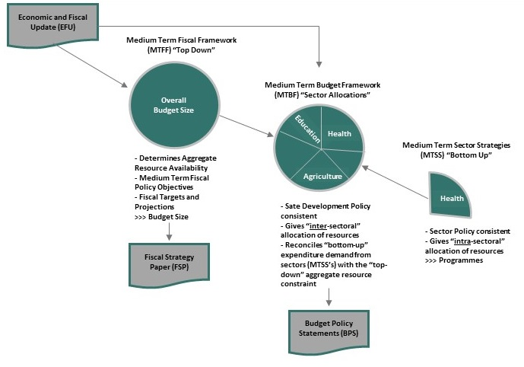

Summary of Document Content
- In accordance with international best practice in budgeting, the production of a combined Economic and Fiscal Update (EFU), Fiscal Strategy Paper (FSP) and Budget Policy Statement (BPS) is the first step in the budget preparation cycle for Plateau State Government (PLSG) for the period 2024-2026.
- The purpose of this document is three-fold:
- To provide a backwards looking summary of key economic and fiscal trends that will affect the public expenditure in the future - Economic and Fiscal Update;
- To set out medium term fiscal objectives and targets, including tax policy; revenue mobilisation; level of public expenditure; deficit financing and public debt - Fiscal Strategy Paper and MTFF; and
- Provide indicative sector envelopes for the period 2024-2026 which constitute the MTBF.
- The EFU is presented in Section 2 of this document. The EFU provides economic and fiscal analysis in order to inform the budget planning process. It is aimed primarily at budget policy makers and decision takers in the Plateau State Government. The EFU also provides an assessment of budget performance (both historical and current) and identifies significant factors affecting implementation. It includes:
- Overview of Global, National and State Economic Performance;
- Overview of the Petroleum Sector;
- Trends in budget performance over the last six years.
- The FSP is a key element in the PLSG Medium Term Expenditure Framework (MTEF) process and annual budget process. As such, it determines the resources available to fund the Government’s growth and poverty reduction programme from a fiscally sustainable perspective.

Preparation and Audience
- The purpose of this document is to provide an informed basis for the 2024-2026 budget preparation cycle for all of the key Stakeholders, specifically:
- State House of Assembly (SHoA);
- Executive Council (ExCo);
- Ministry of Budget and Economic Planning;
- Ministry of Finance;
- All Government Ministries, Departments and Agencies (MDA's);
- Civil Society.
- The document is prepared within the first two quarters of the year prior to the annual budget preparation period. It is prepared by Plateau State Government (EFU-FSP-BPS) Working Group using data collected from International, National and State organisations.

Background

Legislative and Institutional arrangement for PFM
- Legislative Framework for PFM in Plateau State – The fundamental law governing Public Financial Management in Nigeria and Plateau State in particular is the 1999 Constitution. It is required by the Constitution that all revenues accruing to Plateau State Government shall be received into a Consolidated Revenue Fund (CRF) i.e. Single Treasury Account (TSA) to be maintained by the Government and revenue cannot be paid into any other fund, except as authorized by the Plateau State House of Assembly (PLSHA) for a specific purpose. The withdrawal of funds from the CRF shall be authorized by the PLSHA through the Annual Budget or Appropriation process. The Governor of Plateau State shall prepare and lay expenditure proposals for the coming financial year before the PLSHA, and the PLSHA shall approve the expenditure proposal by passing an Appropriation Law. The Appropriation Law shall authorize the executive arm of government to withdraw and spend the amounts specified from the CRF.
- The Constitution requires that the Auditor General of the State shall audit all public accounts of various arms of State government and submit a report to the PLSHA within 90 days of receipt of the financial statement and annual accounts of the Accountant General. The Auditor General of State shall not directly audit the accounts of public enterprises and autonomous government agencies. The office holder shall provide the enterprises and agencies with a list of external auditors to choose from, provide guidelines on fees to be paid, make comments on the accounts and the audit reports, and conduct periodic checks on the enterprises and agencies.
- Apart from the Nigerian Constitution, Plateau State has a set of laws and regulations that regulate its Public Financial Management operations. The laws are Plateau State Audit Law, 2021; Plateau State Planning Commission Law, 2001 which informed the establishment of Ministry of Budget and Economic Planning; and the Revised Plateau State Bureau for Public Procurement Law (PSBPPL) 2018; Plateau State Debt Management Law. In addition, the Financial Regulation and Instruction issued by State to include; Plateau State Cash Management Strategy; Plateau State Arrears Clearance Framework, which provides detailed rules and guidelines to support accounting, internal audit and stores procedures.
- Plateau State Government has Public Service Rules that further define the roles of public officers in the PFM system. The Rules detailed Human Resource Management (HRM) processes and tools including, job descriptions, roles and responsibilities, recruitment, career, discipline, and boarding procedures.
- Institutional Framework for PFM in Plateau State – In Plateau State PFM system; the executive powers include discharge of the expenditure functions of the State Government, Revenue Mobilization and Fiscal Management. The Executive Governor of Plateau State exercises these executive powers directly or through the Deputy Governor, the Commissioners, Special Advisers, Permanent Secretaries and other Officers in the Public Service of the State.
- The Plateau State Executive Council (EXCO) sets the priorities of the State Government, considers and recommends the state budget to the House of Assembly. On passage, the Governor signs the appropriation bill into law. Before sending the state budget to the House of Assembly, it is expected that MTEF/FSP document is prepared, endorsed by EXCO and approved by a simple resolution of the House of Assembly.
- The Ministry of Finance is the main organ of the EXCO for the formulation and execution of fiscal policy. The functions of Ministry of Finance include financial policy, borrowing, investment, loans, and advances, banking and treasury, boards of survey and boards of enquiry, etc. The Ministry of Finance has two important quasi-autonomous agencies, the Office of the Accountant General for the State (OAGS) and the Plateau State Internal Revenue Service (PSIRS). Specific functions of the OAGS include, maintenance of Accounting Policies and Procedures, Supervision and Inspection of the accounting operations of all MDAs, Inspection and Monitoring of all revenue collectors, accounting for the State Government revenue and expenditure, safe custody of all revenue-earning books including license books, etc. The OAGS is also responsible for funds management, expenditure control, including all MDAs, investment of surplus short-term funds, compilation of monthly and annual financial statements of accounts, treasury operations, maintenance of accounts, local and foreign, and internal audit, among others. The OAGS also deploys and posts accounting staff to MDAs.
- The PSIRS have the responsibility to control and administer the various taxes, non-tax revenues and laws specified in the First Schedule or other Laws made or to be made from time to time by the Plateau State House of Assembly or other Regulations made therein by the Government of the State and to account for all such taxes and non-tax revenues collected in the State. The Service formulates and executes policies in the areas of taxation, duties, licensing, fees, fines, sales and other revenues accruing from other MDAs.
- The Plateau State Ministry of Budget and Economic Planning was established in March, 2018, from the State Planning Commission which was established by Law (2001). The Ministry coordinates the formulation, development and production of the state budget and economic development plans e.g. Medium-Plateau State Development Strategy 2019-2023 and long-term, monitors and evaluates the State Government programs and projects including International Cooperation activities.
- The Auditor General of the State, audits and certifies the accounts of the State Government and submits certified reports to the Plateau State House of Assembly. The Auditor General of Local Government performs similar responsibilities at the Local Government level on behalf of the Plateau State Government.
- The State Government allows line agencies some autonomy in expenditure control. Line agencies propose their budgets based on the guidelines issued by the EXCO through the Ministry of Budget and Economic Planning. There are three main categories of expenditure: Personnel Costs, Overhead Costs and Capital Expenditure. The payroll is centralized under the Office of the Head of Civil Service (OHCS). MDAs receive monthly disbursements for general items of overhead costs. They also receive, as the need arises, funds for other specific items of overhead expenditure. MDAs have the responsibility to execute their capital program, but capital funds are released on project-by-project bases.

Overview of Budget Calendar
- Indicative Budget Calendar for Plateau State Government is presented below:
Table 1: Budget Calendar
Stage | Date(s) | Responsibility
Previous Year Budget Performance Review (i.e. Performance Management Review-PMR) | February | MOBEP
Preparation, Endorsement, Approval and Publication of MTEF/FSP | March-April | MOBEP
Update of MTSSs by Sectors | May | MDAs
Preparation and Issuance of Budget Call Circular | June | MOBEP
Preparation of MDA Budget Submissions | July | MDAs
Budget Negotiations | August – Sept. | MoBEP and MDA’s
Compilation of Draft Budget | October | MOBEP
Review and Approval of Budget by EXCO | November | EXCO
Review and Approval of Budget by PLSHA | November –Dec. | PLSHA
Signing of the Appropriation Bill | December | H.E Governor

Economic and Fiscal Update

Economic Overview

Global Economy
- Countries selected are chosen to represent G20, BRINCS, MINT, N-11, Petro-economies and other large African countries.
- Global growth is projected to fall from an estimated 3.4 % in 2022 to 2.9 % in 2023, then rise to 3.1 % in 2024. The forecast for 2023 is 0.2 percentage point higher than predicted in the October 2022. World Economic Outlook (WEO) but below the historical (2000- 19) average of 3.8 %. The rise in central bank rates to fight inflation and Russia’s war in Ukraine continue to weigh on economic activity. The rapid spread of COVID-19 in China dampened growth in 2022, but the recent reopening has paved the way for a faster-than expected recovery. Global inflation is expected to fall from 8.8 % in 2022 to 6.6 % in 2023 and 4.3 % in 2024, still above pre-pandemic (2017–19) levels of about 3.5 %.
- The balance of risks remains tilted to the downside, but adverse risks have moderated since the October 2022 WEO. On the upside, a stronger boost from pent-up demand in numerous economies or a faster fall in inflation are plausible. On the downside, severe health outcomes in China could hold back the recovery, Russia’s war in Ukraine could escalate, and tighter global financing conditions could worsen debt distress. Financial markets could also suddenly reprice in response to adverse inflation news, while further geopolitical fragmentation could hamper economic progress.
- In most economies, amid the cost-of-living crisis, the priority remains achieving sustained disinflation. With tighter monetary conditions and lower growth potentially affecting financial and debt stability, it is necessary to deploy macro prudential tools and strengthen debt restructuring frameworks. Accelerating COVID-19 vaccinations in China would safeguard the recovery, with positive cross-border spill overs. Fiscal support should be better targeted at those most affected by elevated food and energy prices, and broad-based fiscal relief measures should be withdrawn. Stronger multilateral cooperation is essential to preserve the gains from the rules based multilateral system and to mitigate climate change by limiting emissions and raising green investment.
- The global fight against inflation, Russia’s war in Ukraine, and a resurgence of COVID-19 in China weighed on global economic activity in 2022, and the first two factors will continue to do so in 2023.
- Despite these headwinds, real GDP was surprisingly strong in the third quarter of 2022 in numerous economies, including the United States, the euro area, and major emerging market and developing economies. The sources of these surprises were in many cases domestic: stronger-than-expected private consumption and investment amid tight labour markets and greater-than-anticipated fiscal support. Households spent more to satisfy pent-up demand, particularly on services, partly by drawing down their stock of savings as economies reopened. Business investment rose to meet demand. On the supply side, easing bottlenecks and declining transportation costs reduced pressures on input prices and allowed for a rebound in previously constrained sectors, such as motor vehicles. Energy markets have adjusted faster than expected to the shock from Russia’s invasion of Ukraine.
- In the fourth quarter of 2022, however, this uptick is estimated to have faded in most—though not all––major economies. US growth remains stronger than expected, with consumers continuing to spend from their stock of savings (the personal saving rate is at its lowest in more than 60 years, except for July 2005), unemployment near historic lows, and plentiful job opportunities. But elsewhere, high-frequency activity indicators (such as business and consumer sentiment, purchasing manager surveys, and mobility indicators) generally point to a slowdown.
- COVID-19 deepens China’s slowdown. Economic activity in China slowed in the fourth quarter amid multiple large COVID-19 outbreaks in Beijing and other densely populated localities. Renewed lockdowns accompanied the outbreaks until the relaxation of COVID-19 restrictions in November and December, which paved the way for a full reopening. Real estate investment continued to contract, and developer restructuring is proceeding slowly, amid the lingering property market crisis. Developers have yet to deliver on a large backlog of presold housing, and downward pressure is building on house prices (so far limited by home price floors). The authorities have responded with additional monetary and fiscal policy easing, new vaccination targets for the elderly, and steps to support the completion of unfinished real estate projects. However, consumer and business sentiment remained subdued in late 2022. China’s slowdown has reduced global trade growth and international commodity prices.
- Monetary policy starts to bite. Signs are apparent that monetary policy tightening is starting to cool demand and inflation, but the full impact is unlikely to be realized before 2024. Global headline inflation appears to have peaked in the third quarter of 2022 (Figure 1). Prices of fuel and nonfuel commodities have declined, lowering headline inflation, notably in the United States, the euro area, and Latin America. But underlying (core) inflation has not yet peaked in most economies and remains well above pre-pandemic levels. It has persisted amid second-round effects from earlier cost shocks and tight labor markets with robust wage growth as consumer demand has remained resilient. Medium-term inflation expectations generally remain anchored, but some gauges are up. These developments have caused central banks to raise rates faster than expected, especially in the United States and the euro area, and to signal that rates will stay elevated for longer. Core inflation is declining in some economies that have completed their tightening cycle—such as Brazil. Financial markets are displaying high sensitivity to inflation news, with equity markets rising following recent releases of lower inflation data in anticipation of interest rate cuts (Box1), despite central banks’ communicating their resolve to tighten policy further. With the peak in US headline inflation and acceleration in rate hikes by several non-US central banks, the dollar has weakened since September but remains significantly stronger than a year ago.
- Winter comes to Europe. European economic growth in 2022 was more resilient than expected in the face of the large negative terms-of-trade shock from the war in Ukraine. This resilience––which is visible in consumption and investment data for the third quarter––partly reflects government support of about 1.2 % of European Union GDP (net budgetary cost) to households and firms hit by the energy crisis, as well as dynamism from economies reopening. Gas prices have declined by more than expected amid higher non-Russian pipeline and liquefied natural gas flows, compression of demand for gas, and a warmer-than-usual winter. However, the boost from reopening appears to be fading. High-frequency indicators for the fourth quarter suggest that the manufacturing and services sectors are contracting. Consumer confidence and business sentiment have worsened. With inflation at about 10 % or above in several euro area countries and the United Kingdom, household budgets remain stretched. The accelerated pace of rate increases by the Bank of England and the European Central Bank is tightening financial conditions and cooling demand in the housing sector and beyond.
- The forecast of low growth in 2023 reflects the rise in central bank rates to fight inflation––
especially in advanced economies––as well as the war in Ukraine. The decline in growth in 2023 from 2022 is driven by advanced economies; in emerging market and developing economies, growth is estimated to have bottomed out in 2022. Growth is expected to pick up in China with the full reopening in 2023. The expected pickup in 2024 in both groups of economies reflects gradual recovery from the effects of the war in Ukraine and subsiding inflation. Following the path of global demand, world trade growth is expected to decline in 2023 to 2.4 %, despite an easing of supply bottlenecks, before rising to 3.4 % in 2024.
- These forecasts are based on a number of assumptions, including on fuel and nonfuel commodity
prices, which have generally been revised down since October, and on interest rates, which have
been revised up. In 2023, oil prices are projected to fall by about 16 %, while nonfuel commodity prices are expected to fall by, on average, 6.3 %. Global interest rate assumptions are revised up, reflecting intensified actual and signalled policy tightening by major central banks since October.

Table 2: Real GDP Growth - Selected Countries
Country | Actual |  |  |  | Forecast
 | 2019 | 2020 | 2021 | 2022 | 2023 | 2024 | 2027
Mexico | 0.2% | -7.99% | 4.72% | 3.07% | 1.82% | 1.57% | 1.82%
Indonesia | 5.02% | -2.07% | 3.69% | 5.34% | 4.97% | 5.38% | 5.12%
Turkey | 759.45 | 720.11 | 817.51 | 905.53 | 1029.30 | 1087.05 | 1272.78
United States | 2.3% | -2.77% | 5.95% | 2.07% | 1.58% | 1.06% | 2.12%
Germany | 1.05% | -3.69% | 2.63% | 1.55% | -0.29% | 1.5% | 1.34%
United Kingdom | 2.43% | 2.22% | 2.26% | 2.27% | 2.2% | 2.16% | 2.09%
China | 5.95% | 2.24% | 8.45% | 2.99% | 5.24% | 4.48% | 3.62%
Ghana | 6.51% | 0.51% | 5.36% | 3.22% | 1.62% | 2.94% | 5.0%
South Africa | 0.3% | -6.34% | 4.91% | 2.04% | 0.1% | 1.82% | 1.4%
Brazil | 1.22% | -3.28% | 4.99% | 2.7% | 0.92% | 1.49% | 2.20%
Source: IMF’s World Economic Outlook, 2023, www.statista.com.
- The statistic depicts Mexico's real gross domestic product (GDP) growth rate from 2019 to 2022, with projections up until 2027. GDP refers to the total market value of all goods and services that are produced within a country per year. It is an important indicator of the economic strength of a country. Real GDP is adjusted for price changes and is therefore regarded as a key indicator for economic growth. In 2022, Mexico's real GDP grew by about 3.07 % compared to the previous year.
- Mexico, having not been dramatically affected by the 2002 South American crisis, has one of the strongest economies in the Americas behind the United States and Canada. By improving its macroeconomic rules and regulations, Mexico improved on many aspects of its economy, most notably inflation. Several goals that the government wanted accomplish were the improvement of infrastructure around the country as well as newer tax laws that would allow for higher income equality.
- Mexico is generally an export-oriented country, with the majority of export goods consisting of electronics, automobiles and agricultural goods. Exports over the past decade have seen continuous growth, with the exception of 2009. This increase in exports is largely due to an increasing number of free trade agreements with international countries, which essentially eliminate tariffs between member countries. However, Mexico imports more than they export, having recorded an annual trade deficit over the past decade. While most economics label this as a negative aspect, other economics believe that trade deficits are associated with positive economic developments.
- The statistic shows the growth in real GDP in Indonesia from between 2019 to 2021, with projections up until 2027. In 2021, Indonesia's real gross domestic product grew by around 3.69 % compared to the previous year.
- Indonesia is a nation with a growing economy and a steadily increasing population. It is estimated that the total population in Indonesia will surpass 255 million inhabitants by 2016 and continue to grow fast. Indonesia reports the fourth-largest population worldwide, and it is also the fifteenth-largest country by total area. The country's biggest contributor to gross domestic product is the industry, with services close behind. In 2013, industry contributed more than 45 % to Indonesia's gross domestic product in Indonesia.
- The economy in Indonesia has been on the rise over the past years, and Indonesia is slowly establishing itself as one of the world’s most powerful economic players. In 2014, Indonesia's gross domestic product (GDP) amounted to more than 856 billion U.S. dollars, that's higher than Saudi Arabia's GDP, for example. GDP is calculated by analyzing the volume and value of goods and services that a country can produce in a specific time period. Emerging markets and developing economies, such as Indonesia, make up around 57 % of global gross domestic product. Another indicator of economic strength is GDP per capita, which helps to assess the quality of life in a country and the growth of the economy. GDP per capita in Indonesia has been estimated to almost quadruple in the time period between 2004 and 2014, indicating an increase in living standards.
- Gross domestic product is the total value of all goods and services produced in a country in a year. It is considered an important indicator of the economic strength of a country. In 2022, GDP in Turkey amounted to around 905.53 billion U.S. dollars.
- Gross domestic product, or GDP for short, not only shows the aforementioned value; by doing so it gives an idea of the state of a country’s economy and standard of living. The higher and more stable a country’s GDP, the better its economic situation. Since GDP is measured consistently worldwide, comparisons between countries are possible and quite reliable.
- Turkey’s gross domestic product has been on a decline for the past years and is estimated to hit rock bottom in 2019, with a projected steep upturn afterwards. At the same time, inflation is set to peak at almost 17.5 % the same year, and unemployment is on the rise. All in all, the figures do not look promising for Turkey, but at least estimations assume a quick recovery. However, this economic development is likely due to the political path the country has chosen in recent years, and it remains to be seen if the forecasts will prove true in the future or if Turkey’s economy needs to brace itself for a further downturn instead.
- The statistic shows the growth rate of the real gross domestic product (GDP) in the United States from 2019 to 2022, with projections up until 2027. GDP refers to the total market value of all goods and services that are produced within a country per year. It is an important indicator of the economic strength of a country. Real GDP is adjusted for price changes and is therefore regarded as a key indicator for economic growth. In 2022, the growth of the real gross domestic product in the United States was around 2.07 % compared to the previous year. See U.S. GDP per capita and the US GDP for more information.
- The gross domestic product (GDP) of a country is a crucial economic indicator, representing the market value of the total goods and services produced and offered by a country within a year, thus serving as one of the indicators of a country’s economic state. The real GDP of a country is defined as its gross domestic product adjusted for inflation.
- An international comparison of economic growth rates has ranked the United States alongside other major global economic players such as China and Russia in terms of real GDP growth. With further growth expected during the course of the coming years, as consumer confidence continues to improve, experts predict that the worst is over for the United States economy.
- A glance at US real GDP figures reveals an overall increase in growth, with sporadic slips into decline; the last recorded decline took place in Q1 2011. All in all, the economy of the United States can be considered ‘well set’, with exports and imports showing positive results. Apart from this fact, the United States remains one of the world’s leading exporting countries, having been surpassed only by China and tailed by Germany. It is also ranked first among the top global importers. Despite this, recent surveys revealing Americans’ assessments of the U.S. economy have yielded less optimistic results. Interestingly enough, this consensus has been mutual across the social and environmental spectrum. On the other hand, GDP is often used as an indicator for the standard of living in a country – and most Americans seem quite happy with theirs.
- The share in the global GDP adjusted for purchasing power parity in the United Kingdom was forecast to continuously decrease between 2023 and 2028 by in total 0.1 %age points. The share is estimated to amount to 2.09 % in 2027.
- Depicted here is the share of a country's gross domestic product in the global gross domestic product. As the International Monetary Fund describes, the GDP (indicating the total value of final goods and services produced during a year) has been adjusted for purchasing power parity and set in relation to the purchasing power adjusted global GDP value.
- In 2020, Germany's real gross domestic product fell by around 3.69 % compared to the previous year.
- Germany’s social market economy is one of the largest worldwide and continues to thrive. One of the strongest industries in Germany is car manufacturing: Several German vehicle manufacturers, like Daimler, Volkswagen, or BMW, are among the major global market players and have brought in billions of euros in revenue in the past years, fuelling the economy for years to come.
- In 2022, the growth of real gross domestic product (GDP) in China amounted to 2.99 %. For 2023, the IMF expects a GDP growth rate of around 5.24 %.
- The current gross domestic product is an important indicator of the economic strength of a country. It refers to the total market value of all goods and services that are produced within a country per year. When analyzing year-on-year changes, the current GDP is adjusted for inflation, thus making it constant. Real GDP growth is regarded as a key indicator for economic growth as it incorporates constant GDP figures. As of 2021, China was among the leading countries with the largest gross domestic product worldwide, second only to the United States which had a GDP volume of almost 23 trillion U.S. dollars. The Chinese GDP has shown remarkable growth over the past years. Upon closer examination of the distribution of GDP across economic sectors, a gradual shift from an economy heavily based on industrial production towards an economy focused on services becomes visible, with the service industry outpacing the manufacturing sector in terms of GDP contribution.
- Another important indicator for economic assessment is the balance of trade, which measures the relationship between imports and exports of a nation. As an economy heavily reliant on manufacturing and industrial production, China has reached a trade surplus over the last decade, with a total trade balance of around 878 billion U.S. dollars in 2022.
- The growth of the real gross domestic product in Ghana was forecast to continuously increase between 2023 and 2027 by in total 5.0 %age points. The growth is estimated to amount to five % in 2028. While the growth was forecast to increase significant in the next years, the increase will slow down in the future.
- Following the definition of the International Monetary Fund, this indicator refers to the annual change in the gross domestic product at constant prices, expressed in national currency units. Here the gross domestic product represents the total value of the final goods and services produced during a year.
- The growth of the real gross domestic product in South Africa was forecast to increase between 2023 and 2027 by in total 1.4 %age points. This overall increase does not happen continuously, notably not in 2025 and 2026. The growth is estimated to amount to 1.4 % in 2027. While the growth was forecast to increase significant in the next years, the increase will slow down in the future.
- Following the definition of the International Monetary Fund, this indicator refers to the annual change in the gross domestic product at constant prices, expressed in national currency units. Here the gross domestic product represents the total value of the final goods and services produced during a year.
- The statistic shows the growth in real GDP in Brazil from between 2018 and 2022, with projections up until 2028. In 2022, Brazil’s real gross domestic product increased by 2.9 % compared to the previous year.
- GDP is a reliable tool used to indicate the shape of a national economy. It is one of the most well-known and well-understood measurements of the state of a country. Gross domestic product, or GDP, is the total market value of all final services and goods that have been produced in a country within a given period of time, usually a year.
- Brazil has undergone a huge economic transformation in the course of the last decade and is now one of the fastest growing economies on the planet. It belongs to the BRIC club of countries, an acronym that refers to the countries Brazil, Russia, India and China, a group of countries which are considered to be at a relatively similar stage of new and advancing economic development. Economic reforms in Brazil have given the country a boost on the international stage, which has helped it to gain significantly in recognition and influence around the world.
- The domestic product growth rate in Brazil is progressing throughout the years. After a minor blip in 2009, when a short recession saw the rate of growth moving slightly backwards, the economy has picked itself up and fought back with an increase of an impressive 7.53 % in 2010. Despite the rapid growth and the perceived increase in Brazilian domestic prosperity, the gap between rich and poor remains distinct. The lower class manifested themselves in the numerous protests that erupted across the South American state in the summer of 2013. For days, hundreds of thousands of Brazilians took to the streets to protest the increase of public transport fares, but the demonstrations evolved into a more general protest against increasing social inequalities among the Brazilian population, despite increased prosperity.

Table 3: Inflation (CPI) - Selected Countries
Country | Actual |  |  |  | Forecast
 | 2019 | 2020 | 2021 | 2022 | 2023 | 2024 | 2027
Mexico | 3.63% | 3.4% | 5.6% | 8.03% | 6.3% | 3.89% | 3.03%
Indonesia | 2.82% | 2.03% | 1.56% | 4.63% | 5.5% | 3.17% | 3.04%
Turkey | 15.1% | 12.25% | 19.6% | 72.31% | 50.58 | 35.17% | 20.02%
United States | 1.8% | 1.25% | 4.69% | 8% | 4.5% | 2.3% | 2%
Germany | 1.35% | 0.37% | 3.21% | 8.46% | 7.19% | 3.53% | 1.95%
United Kingdom | 1.79% | 0.85% | 2.59% | 9.07% | 6.84% | 2.98% | 2%
China | 2.9% | 2.39% | 0.85% | 2% | 2.24% | 1.86% | 2%
Ghana | 7.1% | 9.89% | 9.98% | 27.18% | 20.94% | 14.72% | 6.5%
South Africa | 4.1% | 3.28% | 4.56% | 6.74% | 5.14% | 4.73% | 4.5%
Brazil | 3.7% | 3.21% | 8.3% | 9.28% | 5.03% | 4.79% | 3.05%
Source: IMF’s World Economic Outlook, 2023, www.statista.com.
- This indicator measures inflation based upon the year on year change in the average consumer price index. The latter expresses a country's average level of prices based on a typical basket of consumer goods and services.
- The inflation rate is calculated based on the Consumer Price Index (CPI) for China. The CPI is computed using a product basket that contains a predefined range of products and services on which the average consumer spends money throughout the year. Included are expenses for groceries, clothes, rent, power, telecommunications, recreational activities, and raw materials (e.g. gas, oil), as well as federal fees and taxes. The product basked is adjusted every five years to reflect changes in consumer preference and has been updated in 2020 for the last time. The inflation rate is then calculated using changes in the CPI. As the inflation of a country is seen as a key economic indicator, it is frequently used for international comparison.
- The statistic depicts the average inflation rate in Mexico from 2019 to 2027, with projections up until 2027. The inflation rate measures price changes for a fixed basket of goods which includes a representative selection of goods and services. In 2021, Mexico's average inflation rate was around 5.69 % compared to the previous year.
- Mexico’s gross domestic product (GDP) has been increasing slightly over the last decade, however, its national debt still amounts to almost half of its GDP. The majority of Mexico’s GDP is yielded by the services sector, as a look at the distribution of gross domestic product in Mexico by sector shows. More than 60 % of GDP are generated in this sector; the majority of the Mexican workforce is employed in services. One important contributor to Mexico’s GDP is tourism. The total unemployment rate in Mexico took a turn for the worse during the recession of 2008 and is still to bounce back to previous levels.
- This statistic shows the average inflation rate in Indonesia from 2019 to 2021, with projections up until 2027. In 2021, the average inflation rate in Indonesia amounted to about 1.56 % compared to the previous year.
- The global economy underwent a drastic slump due to the global financial crisis in 2008, which caused a continued increase in the general level of prices of goods and services; the highest recorded global inflation of the past decade took place in 2008, when the global inflation rate increased by more than 6.4 % in comparison with the previous year. As for Indonesia, the country's inflation rate amounted to around 9.8 % in comparison to the previous year.
- After the financial crisis, the Indonesian government implemented several economic reforms and increased exports in order to strengthen the economy. In 2011, Indonesia exported goods with a value of more than 200 billion U.S. dollars. The main export partners of Indonesia are Japan, China and Singapore. As a result of increased exports, the Indonesian economy was able to grow, making Indonesia one of the twenty nations in the world with the largest gross domestic product in 2015.
- The average inflation rate in the United Kingdom was forecast to decrease between 2023 and 2027 by in total 4.8 %age points. This overall decrease does not happen continuously, notably not in 2026. The average inflation rate is estimated to amount to two % in 2027.
- The statistic shows the average inflation rate in Turkey from 2019 to 2022, with projections up until 2027. In 2021, the average inflation rate in Turkey was at around 19.6 % compared to the previous year.
- With a continuously growing gross domestic product /GDP and thus a rising share in the global GDP adjusted for Purchasing Power Parity, Turkey’s economy is one of the largest worldwide. By 2030, Turkey is estimated to be one of the countries with the highest gross domestic product worldwide.
- Import of goods figures and export figures are rising as well, however, the trade balance of Turkey has been in the negative range for several years now with a downwards trend which indicates a serious trade deficit – or in other words: an imbalance between export and import costs; the value of goods Turkey imports is a lot higher than the value of exported goods.
- Main export partners of Turkey for textiles, automotive goods, iron and steel, among other goods, are mostly European countries, with Germany leading the ranking, followed by Iraq, Great Britain, Italy and France. The most important economic sector for Turkey is the services sector, especially the tourism sector, which has experienced a significant boost over the last decade. Thus, Turkey is now among the most popular destinations for visitors of all nations.
- A look at gross domestic product /GDP growth in Turkey shows that the country suffered a brief setback during the economic crisis of 2008, but swiftly recovered and was back in the black by 2010. Turkey’s employment figures hardly suffered at all, they too recovered quickly and are now back to pre-crisis levels.
- This statistic shows the annual inflation rate in the U.S. from 2019 to 2022 with additional projections up to 2027. The data represents U.S. city averages. The base period was 1982-84. In economics, the inflation rate is a measurement of inflation, the rate of increase of a price index (in this case: consumer price index). It is the %age rate of change in prices level over time. The rate of decrease in the purchasing power of money is approximately equal. According to the forecast, prices will increase by 4.5 % in 2023.
- This forecast of U.S. inflation was prepared by the International Monetary Fund. They project a spike in the inflation rate for 2022, followed by a decrease to around roughly two % annual rise in the general level of prices until 2027. This means that a product bought today for about 100 U.S. dollars will cost about 107.68 U.S. dollars next year, and so on. Considering the annual inflation rate in the United States in 2021, a two % inflation rate is a very moderate projection.
- The current spike in inflation in the United States and worldwide is being attributed to the re-opening of economies as the COVID-19 pandemic wanes, the disruption of supply chains due to the war in Ukraine, and pandemic related changes in the labour force. Although the moderate inflation of prices between two and three % is considered normal in a modern economy, countries’ central banks try to prevent severe inflation and deflation to keep the growth of prices to a minimum. Severe inflation is considered dangerous to a country’s economy because it can rapidly diminish the population’s purchasing power and thus damage the GDP.
- The inflation rate in Germany was 1.35 % in 2019. The current rate meets the European Central Bank’s target rate, which is “below, but close to, 2 %.” Many central bankers favour inflation between 2 and 3 %, but Germans in particular would rather risk deflation than too much inflation.
- Central bankers like low, stable inflation because this is a sign of a growing economy. When the economy grows, workers become more productive and spend more, and prices slowly rise. Monetary policy can cause inflation, but Germany has given this responsibility to the European Central Bank (ECB). Importantly, inflation expectations affect inflation, making it a self-fulfilling prophecy.
- During the Eurozone crisis, German politicians were advocating for the ECB to raise interest rates quickly. This would have reduced inflation, possibly causing deflation, but would have presented another hurdle for the struggling Greek economy. This is because of the hyperinflation of the Weimar Republic in the 1920s, when Germans carried their pay home in wheelbarrows because the banknotes had lost so much value. Ever since, Germans often warn that inflation harms pensioners and that personal provisions are necessary in any case. Fortunately for them, this statistic forecasts stable, modest inflation that does not alarm many economists.
- In 2022, the average annual inflation rate in China ranged at around 2.0 % compared to the previous year. Projections by the IMF published in October 2022 expect the inflation rate to reach about 2.2 % in 2023. The monthly inflation rate in China increased in the first half of 2022, but ranged still at a moderate level.
- Among the main industrialized and emerging economies worldwide, China displayed comparatively low inflation in 2021. In previous years, China's inflation ranged marginally above the inflation rates of established industrialized powerhouses such as the United States or the European Union. However, this changed in 2021, as inflation rates in developed countries rose quickly, while prices in China only increased moderately. According to IMF estimates for 2021, Venezuela was expected to be the country with the highest inflation rate, with a consumer price increase of about 500 % compared to 2020. Samoa was estimated to have the lowest price increase worldwide with prices actually decreasing by about three %.
- In 2021, the inflation rate in Ghana amounted to about 9.98 % compared to the previous year. Ghana’s inflation peaked at almost 17.5 % in 2016 and is predicted to decrease to 6.5 % by 2027.
- Ghana’s economy is considered quite stable and fast-growing, and is rich in oil, diamonds, and gold. After struggling in the years around 2015 due to increased government spending and plummeting oil prices, it is now on an upswing again. This is also reflected in the decreasing inflation rate, and other key indicators like unemployment and rapid GDP growth support this theory. However, Ghana’s government debt is still struggling with the consequences of the 2015 crisis and forecast to keep skyrocketing during the next few years.
- South Africa’s inflation has been quite stable for the past years, levelling off between 3.2 and 6.3 %, and is in fact expected to stabilize at around 4.5 % in the future. South Africa is a mixed economy, generating most of its GDP through the services sector, especially tourism. However, the country struggles with unemployment and poverty.
- In 2016, South Africa’s inflation rate peaked at over 6.3 %, and gross domestic product, and thus economic growth , took a hit, a sure indicator that something was affecting the country’s economic scaffolding: Low growth due to weak demand and an uncertain political future caused a crisis; then-President Jacob Zuma’s alleged mismanagement and unstable reign steeped in controversy and criminal charges even caused the economy’s outlook to be downgraded by ratings agencies. Zuma was relieved of his office in 2018 – ever since, inflation, GDP, and economic growth seems to have stabilized.
- In 2020, the inflation rate in Brazil amounted to about 3.21 % compared to the previous year, a slight increase from the previous year’s 3.73 %, but a large improvement compared to 2015 with more than 9 %.
- Brazil is not only one of the largest countries in the world, it is also one of the largest economies and a member of the so-called BRIC states, four up-and-coming emerging economies. Unfortunately, Brazil also struggles due to an on-going recession; In 2017, the majority of Brazilians described the state of the country’s economy as “bad”.
- Brazil’s mixed economy suffered a severe political and economic crisis in 2014 that only ended in 2016. The country’s GDP slumped dramatically and inflation skyrocketed. As of today, Brazil has recovered, GDP is on the rise again, and inflation is below four per cent – however, as a result of the recession that saw millions of job cuts, unemployment is at an all-time high.

Africa
Real gross domestic product (GDP) in Africa rebounded strongly in 2021, growing by 6.9 per cent. This rebound was supported by recovery in global demand; higher oil prices benefiting oil-exporting economies, easing of COVID-19 restrictions in most countries, and associated growth in domestic consumption and investment. Africa’s real GDP growth is, however, projected to decelerate to 4.1 per cent in 2022, reflecting ebbing of base effects and uncertainties related to the persistence of the COVID-19 pandemic and the impact of the Russia–Ukraine conflict
- Growth varies widely across countries and regions. Economic growth in 2021 was highest in North Africa (11.7 per cent) and East Africa (4.8 per cent). In 2022, growth is expected to decelerate to 4.5 per cent in North Africa and to stabilize at 4.7 per cent in East Africa. Average growth in 2021 in West Africa was 4.3 per cent and is projected to remain strong at 4.1 per cent in 2022. Growth in Central Africa is projected to rise to 4.6 per cent in 2022, from 3.4 per cent in 2021. Southern Africa’s estimated growth of 4.2 per cent represented the largest recovery, from a contraction of 6.0 per cent, underpinned by strong recovery in Botswana (12.5 per cent), Mauritius (4.0 per cent), and South Africa (4.9 per cent). Growth in the region is projected to decelerate to 2.5 per cent in 2022 as the effects of large fiscal stimuli peter out
- Africa’s estimated real GDP growth in 2021 surpassed the world average and that of other regions. According to the International Monetary Fund’s (IMF) World Economic Outlook (April 2022), the global economy grew by 6.1 per cent in 2021, led by Asia. The strong recovery in Africa was due to near full re-opening of economies following easing of COVID-19 infections and deaths. The expansion was also underpinned by strong unexpected recovery in Libya as improvements in political conditions led to a rebound in oil production and exports. Improvement in economic activity was reflected in higher Purchasing Managers’ Index (PMI) values in four of Africa’s top six economies. In 2021, the PMI value in Egypt, Kenya, Nigeria, and South Africa (which together accounted for 52 per cent of Africa’s GDP in 2021) was mostly above the 50 benchmark and closer to pre-pandemic levels. The upturn on the PMI was supported by the easing of restrictions as economies continue to adapt to the pandemic and by policy measures to spur economic resurgence. Improved global financial conditions buoyed by the discovery of COVID-19 vaccines since the third quarter of 2020 have also supported Africa’s recovery. Russia’s invasion of Ukraine has stoked rising uncertainty and amplified volatility in financial and capital markets, the latter of which are also responding to expectations of monetary policy normalization in the United States and the Euro area. Thus, following the outbreak of the Russia– Ukraine conflict in February 2022, the PMI value for four of Africa’s six largest economies fell in March 2022. The impact of the conflict is also reflected in weakening global financial markets.
- The Russia–Ukraine conflict began as the global economy was gradually recovering from the negative effects of the COVID-19 pandemic and as pent-up demand amid persistent gridlock in global value chains stoked a surge in commodity prices, fuelling strong inflationary pressures. Russia’s invasion of Ukraine and the associated sanctions on Russia have imposed costs and volatility on the global economy, transmitted through three main channels—energy and non-energy commodity prices, supply-chain disruptions, and financial markets. These have direct and indirect implications for African economies.
- Both Russia and Ukraine are key players in the global agro-food market and account for more than 25 per cent of the world’s trade in wheat, more than half the global trade in sunflower oil, and 30 per cent of global barley exports.1 This dominance poses a major challenge for Africa. In 2020, wheat and maize accounted for 41.6 % (or $3.5 billion) of Russia’s $8.5 billion merchandise exports to Africa. In the case of Ukraine, wheat, maize, and vegetable fats and oils accounted for 58 per cent ($3.8 billion) of exports to Africa.
- Following disruptions in the production and transportation of agricultural supplies from both countries, food prices have soared to record levels. By April 2022, global wheat prices were up 72.5 per cent from the corresponding period in 2021, and corn prices were up 21.9 %. On a continent where 50–70 per cent of household spending is on food, disruptions to agriculture production and supply chain have implications for food security and inflation, as well as poverty, especially in the low-income countries that depend on Russia and Ukraine for imports of food and other agricultural products.2 The rise in food prices has fuelled inflationary pressures, which could exacerbate malnutrition and poverty among Africa’s poor people, who allocate a greater share of their household income to food.
- The surge in prices of food, energy, and other commodities will, however, create winners and losers across Africa. Energy-exporting countries stand to gain from higher than predicted prices, provided these countries have excess production capacity to respond to the positive price shock and shore up export earnings. For energy- and net food-importing countries, higher energy and other commodity prices coupled with prolonged gridlock in global supply chains could exacerbate inflationary pressures. Given that most African countries are net energy importers—as they export crude oil and import refined petroleum products due to lack of domestic refining capacity—the overall economic impacts are on the downside. Indeed, while net oil- and other commodity–exporting countries could benefit from higher prices, the impact on net energy- and commodity-importing peers is likely to offset these gains, resulting in higher inflation and constrained economic activity. This could slow economic recovery from the impacts of the COVID-19 pandemic. Net crude oil-exporting countries with fuel subsidy regimes could experience fiscal shocks due to the higher price of imported refined petroleum products.
- Africa’s growth outlook is highly uncertain, with risks tilting to the downside. The spill-over effects from the Russia–Ukraine conflict and related sanctions on Russia may cause a larger decline in global output than currently projected. A combination of low COVID-19 vaccination rollout and emergence of new COVID-19 variants may force countries to retain some restrictions. Other downside factors include heightened debt vulnerabilities, tight global financial conditions as inflationary pressures rise, the effect of the Russia–Ukraine conflict and related sanctions on Russia, climate and environmental risks, and other socio-political and security issues. Upside factors include faster vaccination rollout, a comprehensive resolution of debt problems, and policies to accelerate structural transformation and build economic resilience.
- Macroeconomic fundamentals have generally improved, but considerable challenges remain in the medium term, due largely to persistence of the pandemic effects and volatility induced by the impact of the Russia–Ukraine conflict. The average fiscal deficit in Africa is projected to narrow to 4.0 per cent of GDP in 2022, from 5.1 per cent in 2021, reflecting scaling-down of COVID-19-related interventions and relative strengthening of domestic revenues. However, rising commodity prices triggered by the Russia–Ukraine conflict represent a major headwind for the fiscal situation in the short to medium term, especially for economies dependent on imports of energy and food commodities. The average current account deficit is projected to be 2.0 per cent of GDP in 2022, down from 2.4 % in 2021, underpinned by expected narrowing of the trade deficit and current transfers. Exchange rate fluctuations fell in most countries in 2021, supported by improved foreign exchange inflows. The outlook for exchange rates in 2022 and beyond depends on developments in international financial markets, especially on the back of the Russia– Ukraine conflict and normalization of monetary policy in advanced economies. Average inflation is projected to accelerate to 13.5 per cent in 2022 from 13.0 per cent in 2021, fuelled by a sharp rise in commodity prices, especially energy and food, due to escalation of the Russia–Ukraine conflict.
- Sovereign debt remains a threat to economic recovery despite recent debt relief initiatives. Although Africa’s debt-to-GDP ratio is estimated to stabilize around 70 per cent in 2021 and 2022, from 71.4 per cent in 2020, thanks to growth recovery and debt relief measures, it will remain above pre-pandemic levels. The international financial community’s initiatives, such as the Debt Service Suspension Initiative (DSSI), the Common Framework, and the International Monetary Fund’s August 23rd, 2021, general allocation of $650 billion-equivalent Special Drawing Rights (SDRs) have also helped alleviate liquidity pressures in many countries by boosting external buffers. However, these initiatives have not erased debt vulnerabilities, with 23 African countries either in or at risk of debt distress as of February 2022. Additional structural reforms such as debt restructuring and reprioritizing public spending are required to ensure long-term debt sustainability. Reconfiguring the global debt relief architecture, including reinstating the DSSI, will be crucial in supporting debt-ridden African countries’ transition toward a path of sustainable debt in the medium to long term
- Despite a rebound in growth, the impacts of the COVID-19 pandemic on lives and livelihoods in Africa continued in estimates that about 30 million Africans were pushed into extreme poverty in 2021 and that about 22 million jobs were lost in African countries the same year due to the pandemic. These outcomes are likely to continue in 2022 and 2023. When the prolonged effect of economic disruptions stemming from the Russia–Ukraine conflict is accounted for, the number of additional Africans who could be pushed into extreme poverty is estimated to be 1.8 million in 2022 and 2.1 million in 2023. Workers in the informal sector, mainly women and youth, are the hardest hit. In addition, several African countries, such as eSwatini, South Sudan, and Uganda, closed schools for more than 36.7 weeks (the global average from the onset of the pandemic to October 2021)—equivalent to more than a half-year of schooling—eroding the positive trends in education over the past decade. Additional financing needs are estimated at about $432 billion over 2020–22 (a revision from the previously estimated $484 billion due in part to better-than-anticipated fiscal positions) and translated into an average of $144 billion a year over this period to support the recovery.
- Climate finance inflows to Africa have fallen short of the commitments made by developed countries and of the continent’s adaptation and mitigation needs. Between about $1.3 trillion and $1.6 trillion will be needed over 2020– 2030 to implement the continent’s climate action commitments and NDCs, or between $118.2 billion and $145.5 billion annually. Africa’s share in total global climate finance increased by only 3 %age points on average in 2010–19, from 23 per cent (or $48 billion in total) in 2010–15 to 26 per cent (or $73 billion) in 2016–19. If this trend continues, a climate financing gap of $99.9 billion to $127.2 billion a year will remain through 2030, likely undermining Africa’s efforts to support climate resilience and a just energy transition.
- Despite energy being the most funded sector in Africa, resources mobilized so far for the sector are dwarfed by the continent’s enormous energy investment needs. About $15.5 billion (26 per cent of the total) of climate finance inflows to Africa was channelled annually in 2010–19 to the energy sector. However, under the Bank’s New Deal on Energy for Africa, $32–$40 billion in annual investment along the energy value chain is required to achieve universal access to electricity on the continent by 2030, leaving a total annual climate financing gap for energy under the New Deal of $16.5 billion to $24.5 billion. The continent’s large economies—Egypt, Nigeria, and South Africa— account for about 33 per cent of the gap.

Nigerian Economy

Macroeconomic
- Nigeria is a multi-ethnic and culturally diverse federation of 36 autonomous states and the Federal Capital Territory. The political landscape is partly dominated by the ruling All Progressives Congress party (APC) which controls the executive arm of government and holds majority seats at both the Senate and House of Representatives in parliament, and majority of the States.
- High oil prices since 2021 did not boost the performance of the Nigerian economy as has been the case in the past. Rather, macroeconomic stability weakened, amidst declining oil production, a costly petrol subsidy which is consuming a large share of gross oil revenues, exchange rate distortions, monetization of the fiscal deficit, and high inflation. The deteriorating economic environment is leaving millions of Nigerians in poverty. On current trends, with Nigeria’s population growth continuing to outpace poverty reduction, the number of Nigerians living below the national poverty line will rise by 13 million between 2019 and 2025.
- The economy is projected to grow by an average of 2.9% per year between 2023 and 2025, only slightly above the estimated population growth rate of 2.4%. Growth will likely be driven by services, trade, and manufacturing. Downside risks to this growth outlook have intensified, with most of the risks coming from domestic policies, continued low (albeit recently rising) oil production, and scarcity of both foreign exchange and local currency.
- While Nigeria has made some progress in socio-economic terms in recent years, its human capital development ranked only 150 of 157 countries in the World Bank’s 2020 Human Capital Index. The country continues to face massive development challenges, including the need to reduce the dependence on oil for exports and revenues, diversify its foreign exchange sources, close the infrastructure gap, build strong and effective institutions, as well as address governance issues and strengthen public financial management systems.
- Inequality, in terms of income and opportunities, remains high and has adversely affected poverty reduction. The lack of job opportunities is at the core of the high poverty levels, regional inequality, and social and political unrest. High inflation has also taken a toll on household’s welfare and price increases in 2020-2022 have pushed more Nigerians into poverty.
- Extreme weather events such as floods and heat stress have become more severe and frequent, especially in the northern parts of the country. These climate risks have already contributed to declining per-capita food production, such that the proportion of the population facing under-nutrition increased from 6.5% in 2004 to 12.7% in 2020.
- Implementation of critical macroeconomic and structural policy reforms by the newly elected government to be sworn in on May 29, 2023, can place the economy on a stronger and more sustainable path. Some key macroeconomic policy measures include eliminating the petrol subsidy by June 2023, as envisaged in the 2023 fiscal framework, which should be accompanied by strengthened social protection measures.
- Other priorities include adopting a single, market-responsive exchange rate, refocusing the central bank on its mandate to reduce inflation, and increasing non-oil revenues. Economic activity was negatively affected in the first quarter of 2023 by the naira demonetization process, and the extension of the timeframe for its implementation, in line with the March 3, 2023, Supreme Court ruling, will be important to follow through on. Key structural reforms include trade policy, addressing major constraints to productivity such as the large infrastructure gap (notably power), tackling insecurity, as well as addressing climate risks.

Table 4: Nigeria Key Macroeconomic Indicators
Indicator | 2021 | 2022 | 2023 | 2024
GDP Growth (%) | 3.6 | 3.6 | 3.8 | 3.3
GDP (Billion USD) | 440.83 | 440.83 | 454.05 | 469.04
Inflation (%) | 15.63 | 21.34 | 22.41 | 15.8
Exchange Rate (NGN:USD FX Rate) | 657.5 | 449.7 | 655 | 559
Unemployment (%) | 33.3 | 33 | 32.5 | 43
Balance of Payments (% of GDP) | 96.4 | 96.4 | 96.2 | 96.7
Source: (Economic Outlook) National Bureau of Statistics, (WEO) IMF; CBN

Petroleum Sector
- In May 2023, the average price of the OPEC basket was 75.82 U.S. dollars per barrel. Monthly averages have been declining again as rising inflation dampens the global market outlook. The OPEC basket is a weighted average of prices for petroleum blends produced by OPEC countries. OPEC stands for “Organization of the Petroleum Exporting Countries,” and was founded in 1960 in Baghdad, Iraq. The main aim of OPEC is to coordinate the oil policies of its members, and thus to have more influence on the international oil market. It is used as an important benchmark for crude oil prices.
- The OPEC crude oil price is defined by the price of the so-called OPEC (reference) basket. This basket is an average of the prices of petroleum blends that are produced by the OPEC members. The following countries are members of this organization: Algeria, Angola, Congo, Equatorial Guinea, Gabon, Iraq, Iran, Kuwait, Libya, Nigeria, Saudi Arabia, Venezuela, and the United Arab Emirates. Some of these oil blends are, for example: Saharan Blend from Algeria, Basra Light from Iraq, and Arab Light from Saudi Arabia. The OPEC reference basket includes both heavy and light crude oils, and is heavier than most other crude oil mixtures (benchmarks). OPEC's oil production amounted to 31.7 million barrels per day in 2021.
- The OPEC basket is one of the most crucial benchmarks for crude oil prices worldwide. Other significant benchmarks are UK Brent, West Texas Intermediate (WTI), and Dubai Crude (Fateh). Because there are many types and grades of oil, such benchmarks are indispensable for referencing them on the global oil market. Looking at the OPEC price within the last two years, the lowest price was 40.08 U.S. dollars per barrel in October 2020, a result of over-supply and storage fears.

- Nigeria Crude Oil: Production was reported at 1,380.000 Barrel/Day in Feb 2023 This records an increase from the previous number of 1,308.000 Barrel/Day for Jan 2023 Nigeria Crude Oil Production data is updated monthly, averaging 1,915.000 Barrel/Day from Jan 2002 to Feb 2023, with 254 observations. The data reached an all-time high of 2,496.000 Barrel/Day in Nov 2005 and a record low of 1,015.000 Barrel/Day in Sep 2022 Nigeria Crude Oil Production data remains active status in CEIC and is reported by Organization of the Petroleum Exporting Countries The data is categorized under World Trend Plus’s Association: Energy Sector – Table RB.OPEC.CO: Crude Oil Production: OPEC Members: Monthly
Table 5: Nigeria crude oil Production
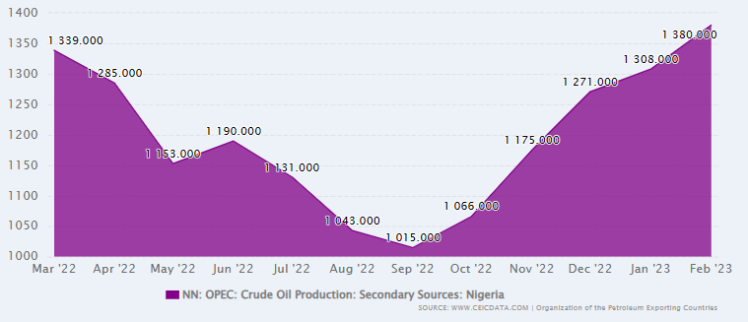
Table 6: Nigeria Petroleum Statistics
Year | Average Actual Price USD (CBN) | FAAC Benchmark Price USD | Average Actual Production (CBN)
2019 | 65.85 | 56.99 | 2.0125
2020 | 41.89 | 39.68 | 1.755833
2021 | 70.12 | 68.17 | 1.308333
2022 | 104.6225 | 94.53 | 1.144167

Plateau State Economy
- Plateau State Known as the “Home of Peace and Tourism” prides itself on its strong agrarian history, status and prospects. According to “States of States Report, 2021”, Plateau State climb to 18th position in 2021 from 34th position in 2020 based on its fiscal performance index. The state may have been able to achieve this by a significant reduction in its recurrent expenditure from N69.21bn in 2019 to N50.15 in 2020: a 27.53% decrease. While there was an increase in capital expenditure (from N19.47bn in 2019 to N20.01bn in 2020) year-on-year and an increase in Internally Generated Revenue (IGR), from N16.48bn in 2019 to N19.12bn in 2020, the said increases were minimal.
- In terms of state debt, Plateau is the 14th most indebted state, at N150.29bn. In the 2019- 2020 fiscal year, it grew by 4.30% moving from N144.09bn to N150.29bn. In terms of external debt, Plateau is the 13th most indebted with a debt liability of $32.92m. In comparison to its regional peers, Plateau ranks the highest in total debt stock.
- With the secured relative peace in the State, it is expected that the tourism industry would blossom given its conducive climatic weather, serene and scenic environment. The State Development Strategy Plan 2019-2023 identified Tourism, Agriculture and Mining as core sectors/pillars of the economy.
- To achieve steady progress in economic growth and development, according to the State Development Strategy 2019-2023 Agriculture, Mining and Tourism are to be given priority in both public and private investments.
- In terms of revenue performance, observations show that Plateau state is quite dependent on allocations from the federation account, as analysis shows this is up to 73.98%. This means that the remaining 26.02%, is the state’s IGR strength. As is apparent, this is an unsafe fiscal position, meaning that the state must (alongside its debt overhang) consider innovative ways of increasing its revenue. However, the present administration has demonstrated strong determination to surpass the past records by transforming the administrative and the enterprise modelling with targets in place. The State Economic rebirth is centred on the Development Strategy 2019-2023 which outlined three (3) Core Sectors; Agriculture, Solid Minerals and Tourism. Sustainable development enablers are; Revenue generation, Physical Infrastructural Development, Human capital Development, Peace and Security, and Governance and Finance. Each of the above has implementable initiatives to drive the realization of Plateau Economic Rebirth. This however, demonstrated Government empirical commitment to harness and utilized the State natural resources within the medium term. The above is also in line with Federal Government Medium Term Development Programme tagged Economic Recovery and growth Plan (ERGP) 2017-2020, to diversify the economy to non-oil sector. The economic fundamentals especially, Macroeconomics indices of the state are directly linked to the national guides on the affected specific variables.
- Taking a closer look at the nature of change in capital expenditure, it was observed that capex only grew by 2.80% (i.e., from N19.47bn in 2019 to N20.01bn in 2020) year-on-year. In comparing its spend on capex to its spend on recurrent expenditure, the latter far exceeded the former, with a total of N20.01bn on capex and N50.15bn on recurrent expenditure. However, Plateau was the 11th lowest spender on capex, compared to its fellow subnational units, with Lagos as the highest spender on capex. When capex is dimensioned into per capita spending, it was N4,086 per capita (a figure which is half the national average and more than N2,000 below the national median). In terms of sector prioritization, the state spent N13.73bn on its Economic sector, representing 68.61% of the total allocation towards capex.
- The State Bureau of Statistics, however, need to be strengthened to provide the needed research support to the Ministry of Budget and Economic Planning to avoid over reliance on federal government basic Macroeconomics indices such as Consumer Price Index (CPI), State Real GDP Growth Rate, etc which in most cases does not reflect the true perspective of the State economy, thereby affecting policy framework.

Fiscal Update

Historic Trends

Revenue Side
- On the revenue side, the document looks at Statutory Allocation, Derivation, VAT, IGR, Other Federation Account, and Capital Receipts – budget versus actual for the period 2024-2026 (six year historic) and 2023 budget.
Figure 2: Statutory Allocation
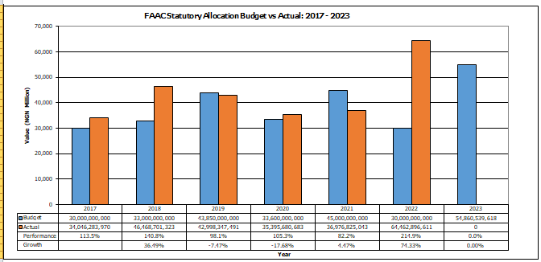

- Statutory Allocation is a transfer from the Federal Allocation Accounts Committee (FAAC) and is based on the collection of mineral (largely Oil) and non-mineral revenues (companies’ income tax, customs, and excise duties at the national level, which is then shared between the three tiers of government using sharing ratios.
- Actual receipts have staggered year on year from 2017 to 2023, with the highest receipt of N64b recorded in 2022. However, the drop in Statutory Allocation for 2020 was occasioned by the global pandemic (COVID-19) which adversely affected global economy and leading to sharp decline in the crude oil price, which is a major source of income to the country, in the international oil market.
- Budgeting has been commendable over the period; however, the State will ensure to improve the margin with the development of a realistic budget. The 2023 Budget, which was premised on the 2024-2026 MTEF (which used scientific forecasting for Federation Account revenues), is a significant step in the right direction in terms of budget realism.
Figure 3: Derivation
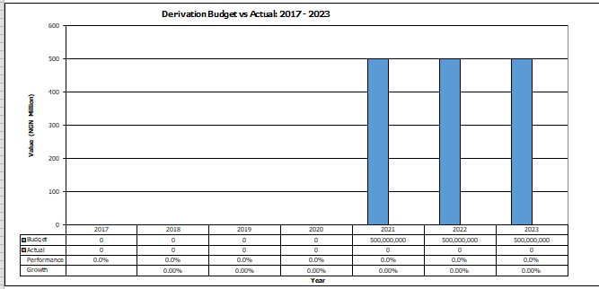

- This is the estimation for Derivation. It is based on elasticity forecast using the macroeconomic assumption explained in the above graph.
- The Derivation Revenue is revenue derived from natural resources. Thirteen (13) per cent of the revenue is shared among the states from which it is obtained, in consonance with the principle of derivation.

Figure 4: VAT
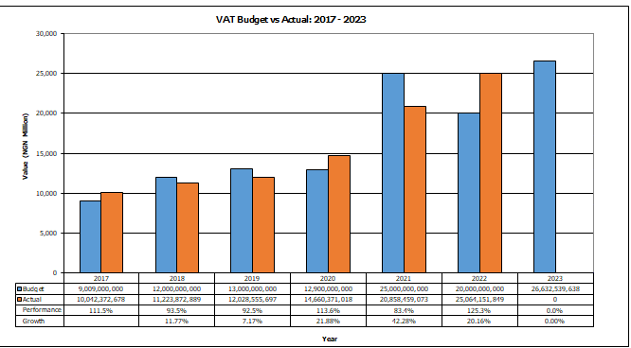

- VAT is an ad valorem tax on most goods and services which has been at a rate of 5% between 2016 and 2019 and increased to and maintained at 7.5% from 2020. It is collected by the Federal Inland Revenue Service (FIRS) and distributed between the three tiers of government monthly – partially based on set ratios, and partially based on the amount of VAT a particular state generated. States receive 50% of the total VAT collections nationally, from which Plateau gets around 2.19% of the state allocation.
- VAT receipts have increased year-on-year from 2017 to 2023 largely due to the growth in nominal economic activities in Nigeria and the recent upward review of the rate from 5% to 7.5% in 2021.
- The steady increase in VAT receipts recorded in the State from 2021 to 2023 is as a result of the relative peace enjoyed in the State as more Businesses and investments have been recorded.
- Forecasts should take into consideration the possible implications of the oil prices on economic activity in Nigeria – elasticity forecasting will enable this.

Figure 5: IGR
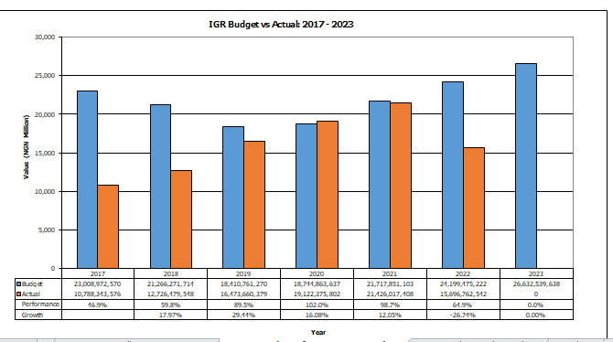

- Internally Generated Revenue (IGR) is revenue collected within Plateau state related to income tax (PAYE represents the highest contributor to IGR), fines, levies, fees, and other sources of revenue within the state.
- IGR has grown at a steady pace year on year from 2017 to 2023 reflecting the commitment and determination of the State at increasing the IGR.
- In the years 2017, 2018 and 2022, the budgeted amount far exceeded the actual collections. This was because of internal revenue targets that were not achieved by the revenue generating MDAs and the security situations of the State affecting economic activities. This has since improved from 2019 with the relative peace and improvement in the performance of the revenue generating MDAs.

Figure 6: Other Federation Account
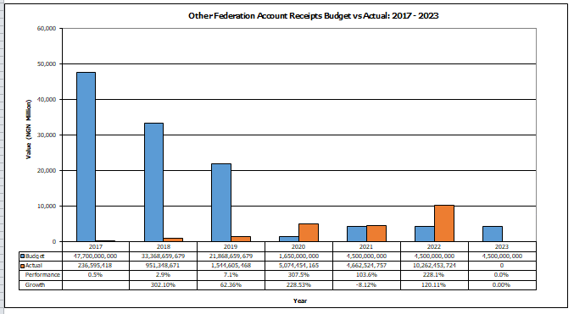

- Other Federation Accounts receipts include Excess crude Accounts distribution, SURE-P, and exchange gains, refunds from NNPC and FIRS, and augmentation. It is generated when actual crude oil price, production, and NGN: USD exchange rates exceed the Budget benchmarks and hence extra revenue is generated.
- 2010-2014 saw significant excess crude distributions including the introduction of SURE-P (the fuel subsidy re-investment programme) in mid-2013. This led to increased expectations (budget) year-on-year. However, from 2017 excess crude distributions dropped significantly and there are little funds left in the excess crude accounts for distribution progressing.
- From the above it is clear that the State over estimated receipts from these sources between 2017 and 2019. Going forward the state needs to take into consideration all important indices in forecasting revenue from these sources as seen between 2020 and 2023.

Figure 7: Grants
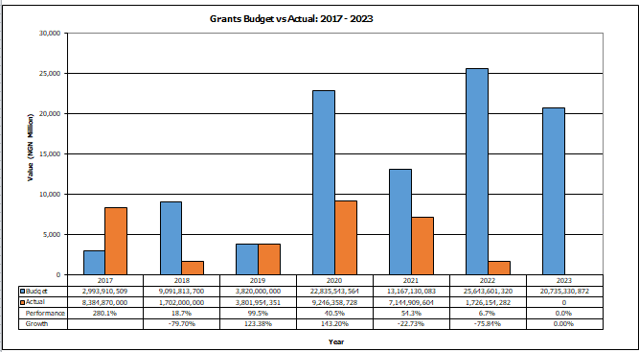

- Grants are receipts from federal government and local governments such as Federal Government MDGs Conditional Grants Scheme, as well as grants from the international development partners (including - United Nations Children’s Fund (UNICEF). Plateau has proactively included as much grant expenditure “on-budget” as is possible, even if the funds don’t travel through the state treasury.
- Performance against budget has been low from 2018 – 2022, whereas 2017 experienced a high performance.
- Grant estimates going forward will be consistent with signed agreements; any “blue-sky” will be specifically linked to the implementation of specific projects.

Figure 8: Other Capital Receipts
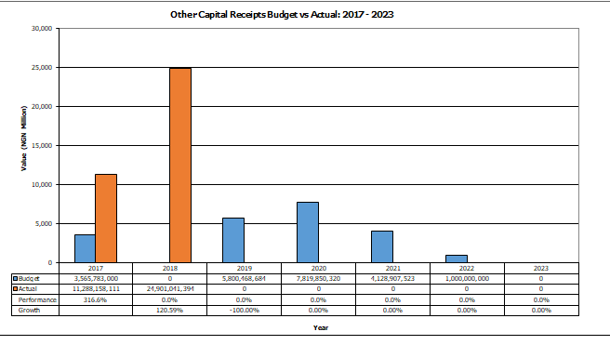

- These are based on expected exceptional incomes, ecological fund from FGN and investment incomes.
- Historically, other capital receipts have related to sale of state assets (mostly housing) and also income from state assets. It also takes into account rebate from Federal Government for roads and other maintenance cost incurred by the state.

Figure 9: Loans/Financing
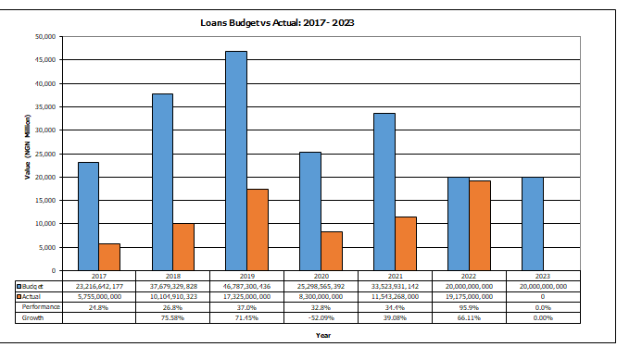

- Besides some short-term borrowing from banking facilities, financing has come in the form of various World Bank programmes.
- The low performance particularly over the years (2017-2021) is because of high and over ambitious estimates of loans for the years, except for 2022 and 2023 which recorded a reduction in budget to 20b respectively from the initial of 31.5b in 2021. Expectations for 2024 onwards should be based on negotiated facilities.

Expenditure Side
- On the expenditure side, the document looks at Consolidated Revenue Fund (CRF) charges, Personnel, Overheads and Capital Expenditure – budget versus actual for the period 2024-2026 (six years) and 2023 budget.

Figure 10: Personnel
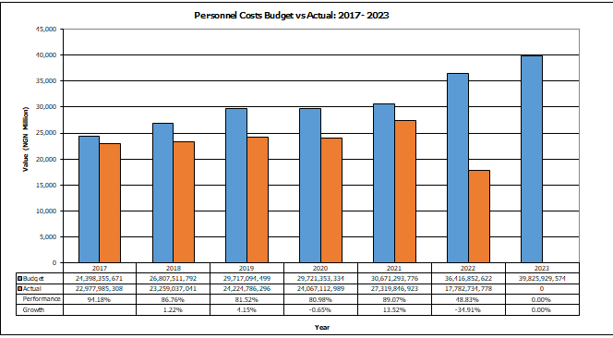

- Personnel expenditure includes salaries and allowances of public and civil servants in the state. The average performance for personal over the period under review is 80.22%. The year with the highest performance is 2017 with 94.18% while the highest in terms of nominal value is N27b in 2021.
- Actual expenditure has been close to budget in all years with exception in 2022.

Figure 11: Social Contributions and Social Benefits
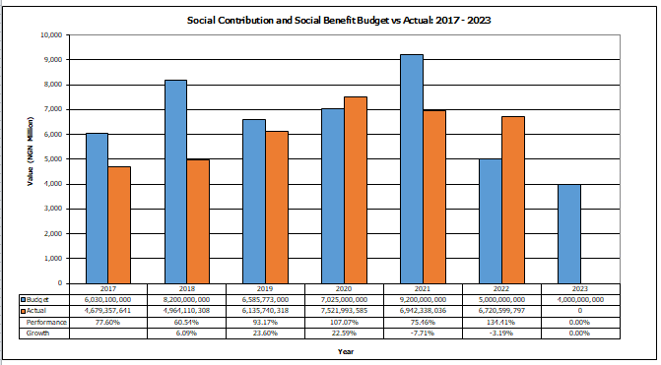

- Social contributions and social benefits represent payment of pension and gratuities to public and civil servants in the state.
- The average performance for social contribution and social benefits was 91.38% over the period of 2017 to 2022 with the State recording the highest performance of 137.41% in 2022.

Figure 12: Overheads
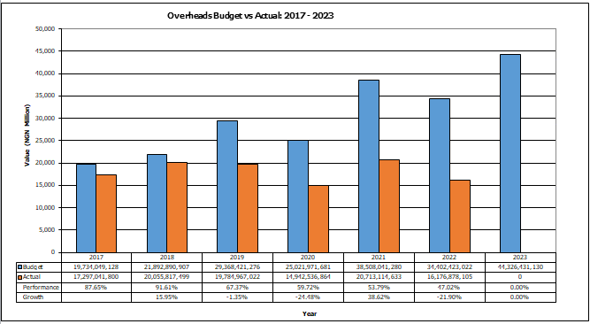

- Overheads comprise mainly of operational and maintenance costs for running day-to-day activities of the Government. Overhead expenditure has been fluctuating over the period as observed – increasing and decreasing year on year culminating in a significant increase. This has been in relation to the available financial resources to the State that has warranted prioritising the disbursement of fund for overhead expenditure.
- The average performance for overhead was 67.86% over the period of 2017 to 2022 with the State recording the highest performance of 91.61% in 2018. The State recorded decline in 2020 due to the global pandemic that affected global economic activities which impacted on revenue available to Government around the world not leaving out Plateau State.

Figure 13: Grants, Contributions, Subsidies, Transfers
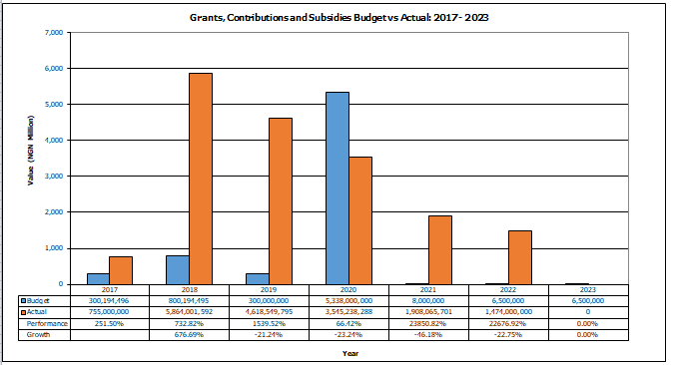

- Grants, contributions subsidies and transfer represent payments to government owned agency to support and augment their activities. Over the years its performance has exceeded the budget except for 2020 where the performance was below budget, and this can be attributed to global pandemic (COVID-19).
- The State has made conscious effort to increase the budgeted amount to Grants, contributions subsidies and transfer as a way of increasing financial resources to the State agencies such as Primary Health Care Development Agency, Plateau State Agricultural Development Program, Plateau State Contributory Health Care Management Agency, and Plateau State University e.t.c.

Figure 14: Public Debt Service
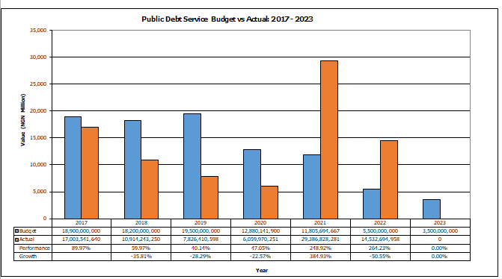

- Public debt charges include interest on un-matured debt and on other accounts, amortisation of premiums and discount on un-matured debt, the servicing costs and cost of issuing new borrowings.
- The actual public debt charges have been on the decrease from 2017 before the sharp increase that occurred in 2021 with the State servicing the debt to the tune of about N29b.
- The passage into law, the Arrears Clearance Framework and Cash Management Strategy in the State in 2020, which defined the %age to be used as a guide over all inflows in the reduction of Public Debt. This improved the payment/reduction of the state public debt service, hence the sharp difference between 2020 - 2022.

Figure 15: Capital Expenditure
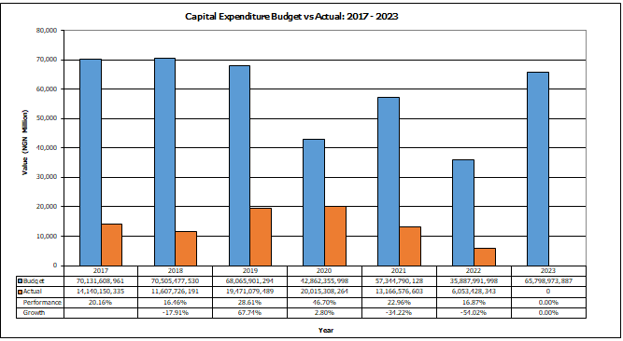

- Capital expenditure refers to projects that generate state assets (e.g., roads, schools, hospitals) – both tangible and in-tangible.
- As above, performance against budget has been very low between 2017 and 2022. The capital projects were proposed in the budget without taking into consideration of realistic revenue to fund the projects.
- The average performance for Capital expenditure was 25.29% over the period of 2017 to 2022 with the State recording the highest performance of 46.7% in 2020.
- Prudent forecasting of revenue, and hence the capital development fund, and tight control on recurrent expenditure, will help both increase the level of capital expenditure and improve performance against budget going forwards. This is important as the state should avoid wasted effort in preparing detailed capital expenditure submissions if they cannot, ultimately, be resource-backed.

Figure 16: Capital Expenditure Ratio
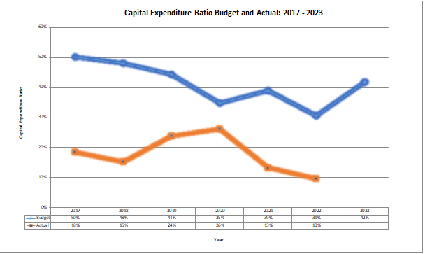

- The capital expenditure performance was highly unstable for all the years. There is a huge gap between the proportion of the total budget allocated for capital expenditure and actual capital expenditure. For example, in 2017, capital expenditure budget was 50% while actual as only 18%. However, 2020 was the only year actual capital expenditure (26%) was not too far from the budgeted (35%).

By Sector
- Performance by Main MDAs was varied over the period 2018-2021 as indicated in Error! Reference source not found.6 (Personnel), Error! Reference source not found. 7 (Overheads) and Error! Reference source not found. 8 (Capital) below.
- As noted above, there was rationing of releases for capital expenditure in all the years due to the shortfalls in revenue.

Table 7: Sector Expenditure – Personnel - Budget Vs Actual
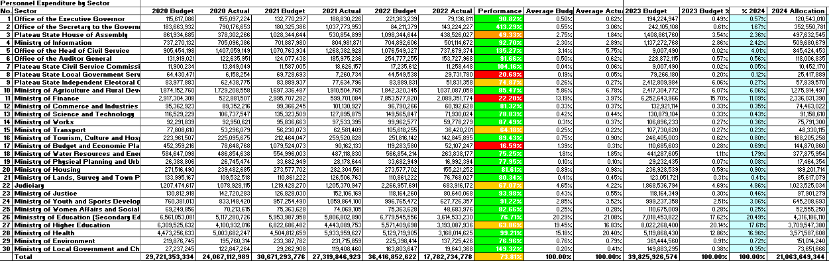

Table 8: Sector Expenditure – Overhead - Budget Vs Actual
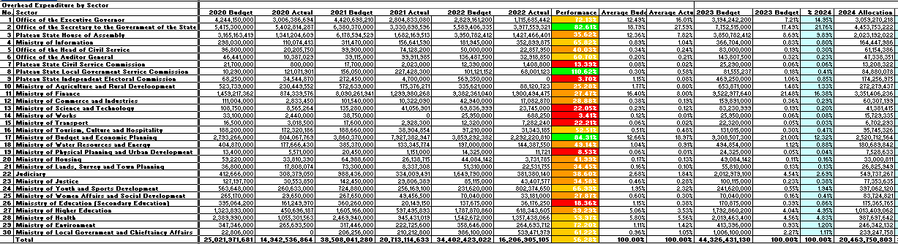

Table 9: Sector Expenditure – Capital - Budget Vs Actual
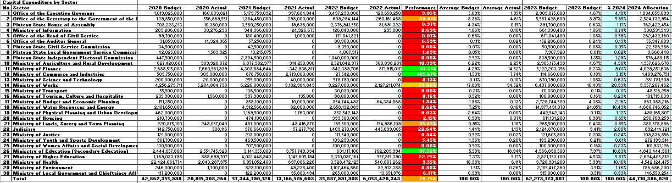

Debt Position
- A summary of the consolidated debt position for Plateau State Government is provided in the table below.
Table 10: Debt Position as at 31st December 2022
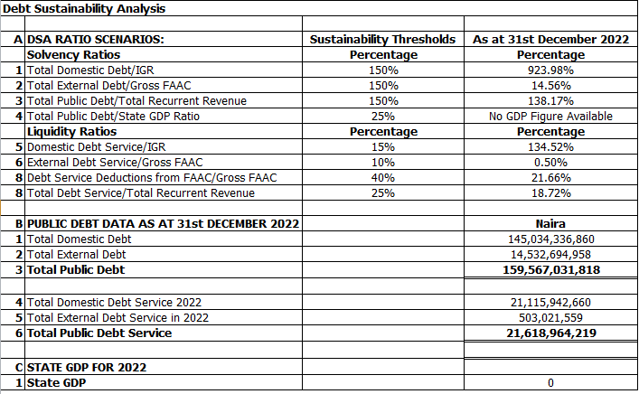

- The State solvency ratios are higher than the sustainability threshold except for total external debt/gross FAAC revenue. The current level of domestic debt is unsustainable and will on the long run effect State performance.
- In terms of the solvency ratios, the State is only able to fall below the sustainability threshold of 150% for Total External Debt to Gross FAAC while total Domestic Debt to IGR and Total Public Debt to Total Recurrent Revenue is above with a %age of 923.98% and 138.17% as at December 2022 respectively.
- The liquidity ratio also mirrors the State’s position for the solvency ratio with the State only able to display a %age below the recommended threshold for External Debt Service to Gross FAAC and Debt Service Deductions from FAAC to Gross FAAC with a %age of 0.50% and 21.66% respectively while Domestic Debt Service to IGR and Total Debt Service to Total Recurrent Revenue is 21.66% and 18.72% respectively.

Fiscal Strategy Paper

Macroeconomic Framework
- The Macroeconomic framework is based on: National Inflation (Consumer Prices) and real GDP growth are taken from the April 2022 IMF World Economic Outlook (WEO) document. The crude oil price and NGN: US$ exchange rate for 2022 is based on the 2021 Federal budget assumptions. The production benchmark, crude oil price and NGN: USD exchange rate for 2023-2025 is based on the figure proposed for Federal Fiscal Strategy Paper 2022-2024
Figure 17: Plateau State Macroeconomic Framework
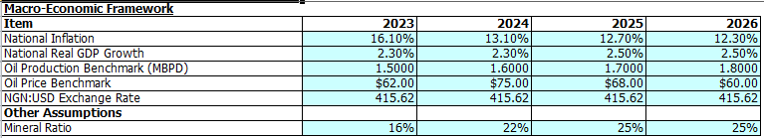

Fiscal Strategy and Assumptions

Policy Statement
- Plateau State Fiscal Policy is laid out as follows:
- The fiscal strategy of Government is anchored on the State Development Strategy 2019-2023. The Fiscal Policy is directed at improving the efficiency and effectiveness of spending within the three core development pillars namely; Agriculture, Mining and Tourism to achieve a better balance between capital and recurrent expenditure. This can be made possible through enhanced Revenue, Physical Infrastructure, Human Capital Development, Peace and Security, Good Governance and Finance;
- Entrench sustainable Government expenditure through the adoption of more accurate revenue estimates and the continued, realistic growth in internally generated revenues i.e. taxes and non-tax revenue; hence, internally generated revenue including capital receipts in real terms in the medium term;
- Plugging revenue leakages and gradual fiscal consolidation to achieve a level of public spending consistent with macroeconomic stability and sustainable debt;
- Ensure sustainable fiscal deficits with appropriate level of public sector borrowing and acceptable aggregate public debt; by keeping the fiscal deficit below 3 % of GDP and total debt service below 30 % of total revenue;
- Tilt capital investment funds towards Government Key priority areas i) Agriculture ii) Mining and iii) Tourism;
- Use the State Development Strategy 2019-2023 and the annual budget to deepen the goals of job creation, poverty eradication and wealth creation;
- Provide for the anticipated increase in wage bill within the State fiscal provision; not exceeding 25 % of total revenue and 35 % of IGR;
- The State may choose to access Development Policy Operations (DPO)7 arrangement of the World Bank on key investment priorities for interventions;
- The need to entrench Programme Based Budget (PBB) & MTSS across all MDAs and Budget profiling for cash management and results purposes;
- Reposition office of the State Auditor General to effectively and efficiently conduct routine Personnel Emolument and Contract Verification exercises within the State MDAs
- Reposition office of the Auditor General, Local Government to effectively and efficiently conduct routine Personnel Emolument and Contract Verification exercises within the Local Government
- Maintain Capital/Recurrent Ratio within acceptable threshold of 60:40;
- Lay greater emphasis on maintenance of public assets;
- Effectively manage parastatal organizations in order to reduce their dependence on the State’s finances by generating more than they spend;
- Foster a robust enabling environment for private investors through PPP initiatives and general investment climate e.g. one-stop-shop, peace and security; and
- Improve fiscal discipline State-wide;
- Boost Government’s tax collection in 2020-2023 through effective and efficient tax policy within a sound tax administrative framework (assessment, enforcement, collection and accountability);
- With the application of policies in line with the objectives and targets outlined above, it is expected that over the medium term, these policies will be applied taking into consideration the development priorities of the State as entrenched in the State Development Strategy 2019-2023;
- The PLSG fiscal guidelines promote revenue growth across MDAs, debt sustainability and income equality redistribution. The fiscal stance targets medium-term consolidation, with moderate expenditure in key identified sectors -Agriculture, Mining and Tourism within the three policy-thrusts; economic rebirth, physical infrastructure development, peace, security and good governance.
- The need to repeal the law on the abandoned property to enable the Ministry of Budget and Economic Planning take ownership on behalf of the State;
- Generally, the fiscal policy aimed at, over the next three years is to keep the fiscal deficit below 3 per cent of GDP as stipulated by international financial management guidelines. Hence target the following:
- Improve impact of spending on Government key priorities (Agriculture, Mining and Tourism)
- Ensure that expenditure grows in line with the expenditure ratio policy of 60:40 capital to recurrent.
- Sustaining the total public debt within the acceptable limit.

Objectives and Targets
- The key targets from a fiscal perspective are:
- Achieve a recurrent to capital expenditure ratio of 40:60 by 2023;
- Create efficiencies and effectiveness in personnel and overhead expenditure to allow greater resource for capital development;
- Grow IGR by a minimum of 10% per annum from 2023 to 2025;
- Loans will only be used for capital expenditure projects with high yielding investments returns;
- Long term target of funding of all recurrent expenditure through revenue of a recurrent nature (IGR, VAT and Non-mineral component of Statutory Allocation);
- Critical MDA’s with revenue heads be supported to generate more revenue with effective tracking mechanisms in place;
- Target sources of capital receipts and financing outside of loans (e.g. Grants, PPP, Donors etc.);
- Priority given to the core sectors (Agriculture, Mining and Tourism), completion of ongoing capital projects that aligns with the key sectors before new projects are commenced.

Indicative Three-Year Fiscal Framework
- The indicative three-year fiscal framework for the period 2024-2026 is presented in the table below.
Table 11: Plateau State Medium Term Fiscal Framework
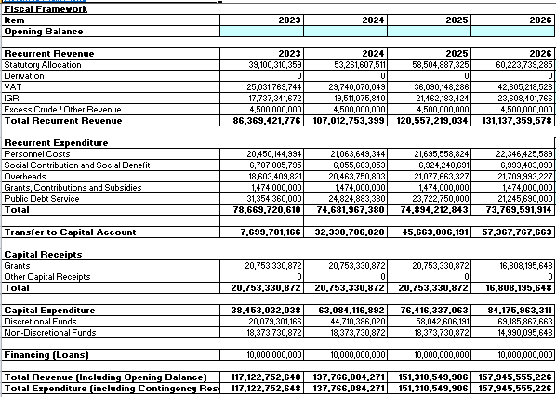

Assumptions
- Opening Balance -
- Statutory Allocation – The estimation for statutory allocation is based on an elasticity forecast taking into consideration the macro-economic framework (National) and the daily crude oil production of 1.5mbpd, 1.6mbpd and 1.7mbpd for 2024, 2025 and 2026 respectively. The crude oil price of $79, $80, and $81 for 2024, 2025 and 2026 respectively with an exchange rate of NGN:US$ of N465.50 proposed. Non-oil revenues flows are elasticity-based forecast using national Real GDP and Inflation data provided in June 16, 2023 WEO.
- Derivation -
- VAT – is also based on elasticity forecasting using national Real GDP and Inflation data as the explanatory variables for VAT growth.
- Excess Crude – This is forecasted using the own value method and based on recent receipts. It is consistent with the provision in the 2023 budget.
- Internally Generated Revenue (IGR) – the projected growth is around 10% per annum for 2023, 2024 and 2025 on the back of an anticipated 13% growth in 2022. The State is is adopting an own %age forecasting method that reflects the planned revenue drive embarked by the State through the Internal Revenue Service.
- Grants – The internal grants are based on existing grants. External grants are based on signed grant agreements with the development partners.
- Miscellaneous Capital Receipts –
- Financing (Net Loans) – Plateau State intends to secure an internal loan/borrowing in for the period the meet the shortfall in the revenue to meet the anticipated expenditure of the State for the period.
- Personnel – the projection of the personnel is based on annual increase of 2% for 2024-2026 following an anticipated increase of 15% in 2023 which is occasioned by the planned recruitment for key sectors particularly the Education sector (Tertiary Institutions), promotion of existing staff to the next grade levels which is long overdue and the domestication/implementation of various Professional bodies fringe benefits as applicable at the Federal Civil Service.
- Social Contribution and Social Benefits – are projected based on own %age annual increase of 1% across the period 2023 to 2025.
- Overheads – are projected based on own %age. The result is that overhead will increase by 15% in 2023, 10% by 2024 and maintain 5% for 2025 and 2026.
- Grants, Contributions, Subsidies and Transfers - it is planned subvention to some MDAs such as Primary Health Care Development Agency, Plateau State Agricultural Development Program, Rural Access and Agricultural Marketing Project, Plateau State Contributory Health Care Management Agency, Plateau State University within the State.
- Public Debt Service - is based on the projected principal and interest repayments for 2024, 2025 and 2026. Hence, an own value has been used based on the submission from the debt management department over the medium term.
- Contingency and Planning Reserves – no provision will be made for contingency and planning reserve.
- Capital Expenditure – is based on the balance from the recurrent account plus capital receipts.

Fiscal Trends
- Based on the above envelope, plus actual figures for 2017-2023 (using the same basis for forecasting as noted in the sub-sections within section 3.B), the trend from historical actual to forecast can be seen for revenue and then expenditure in the line graphs below.

Figure 18: Plateau State Revenue Trend
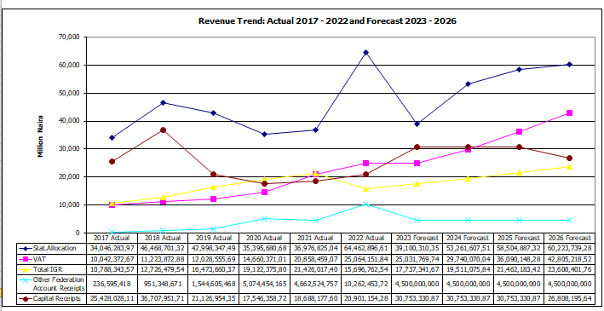

Figure 19: Plateau State Expenditure Trend
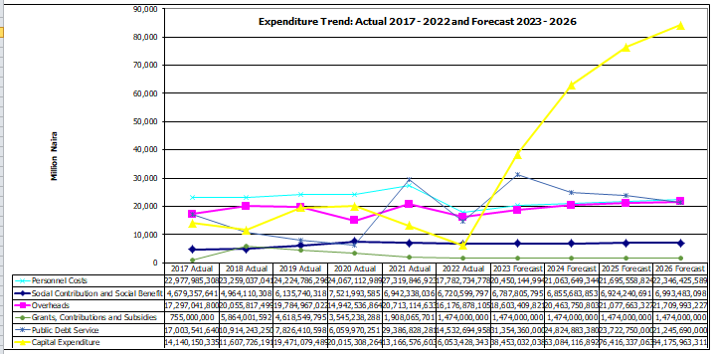

Fiscal Risks
- The analysis and forecasting basis as laid out above implies some fiscal risks, including but not limited to.
Table 11: Fiscal Risks
Risk | Likelihood | Impact | Reaction
Risks to statutory Allocation revenue based on Oil Price or Production shock | High | High | In the longer term, Plateau State must become less dependent on Statutory Allocation – this should be achieved through higher IGR, collection. In the short term, capital projects must be prioritised, and overhead expenditure should be sufficiently flexible for reduction if short fall in revenue occurs.
Security situation country wide could affect economic activity and oil production, resulting in risk to VAT and Statutory Allocation | High | High | The estimates for VAT and Statutory are not overly ambitious. In addition, clear prioritisation of projects in the capital budget is required. Increased IGR effort to decrease reliance on federal transfers and seeking alternative means of funding (grants, PPP, DFI, Donor Assisted etc.)
Mismanagement and inefficient use of financial resources | Low | High | Adherence to existing and new institutional and legal/regulatory framework that will require more transparent and efficient use of financial resources.
Poor Security in the state as well as neighbouring states, resulting in reduced IGR and increased overhead to combat the challenge | High | Medium | Proactive engagement by government to reduce security risks and communities/institutions collaboration
Floods and other natural disasters that will impact on economic activities and hence IGR and causing increased overhead expenditure | High | Medium | Increased investment to increase climate resilience, advocacy awareness and control measures
- It should be noted however that no budget is without risk. The ongoing implementation of the 2023 budget should be closely monitored, as should the security situation and impact of the fiscal and economic outlook.

Budget Policy Statement

Budget Policy Thrust
- The current 3-Point Policy Thrust of this Administration are captured by the following points:
- Peace, security and good governance;
- Physical infrastructure development;
- Sustainable Economic rebirth
- The Direction in managing the economy in the medium term involves the government's priority in supporting the sustainable economic growth and development along with the fiscal sustainability. Therefore, in managing expenditures of the public sector, the government adheres to the policy on achieving the operating targets, transparency, efficiency, and risk aversion in order to implement the government's policies leading to the direct benefits of the people.
- In preparing the Y2024 budget, and outer 2025 & 2026 budgets, State government could set the following budget policy:
- Realistic Budget Policy that should stand the economic challenges where expenditure equals Revenue.
- Improve managerial efficiency with the aim to reduce public spending and blocking leakages.
- Government agencies could be urged to prioritised operations which have short term return on investment by eliminating redundancies at all levels so as to economize operating expenses and enhance efficiency.
- The Plateau State Development Strategy 2019-2023 (PSDS) sets out strategic development agenda. It provides government with a clear and progressive foundation to economic rebirth encompassing the livelihood of the society.

Sector Allocations (3 Year)
- Presented in the table below are the indicative three envelopes for sectors / Main Orgs.
Table 12: Indicative Sector Expenditure Ceilings 2024-2026- Personnel Expenditure
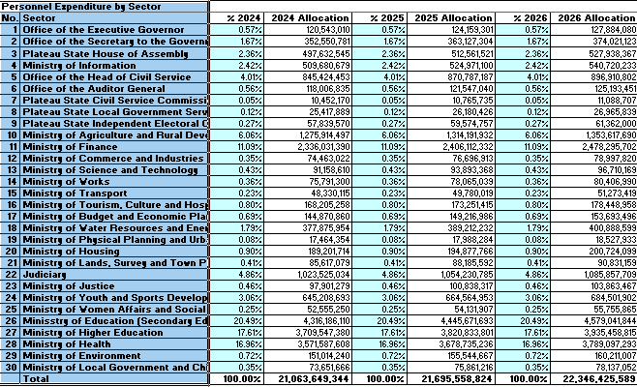

Table 13: Indicative Sector Expenditure Ceilings 2024-2026- Overhead Expenditure
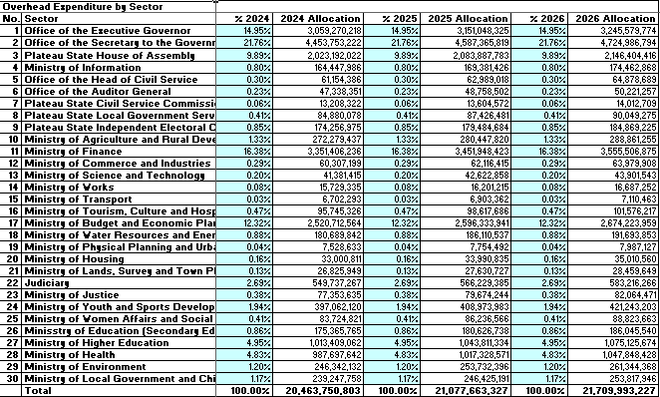

Table 14: Indicative Sector Expenditure Ceilings 2024-2026- Capital Expenditure
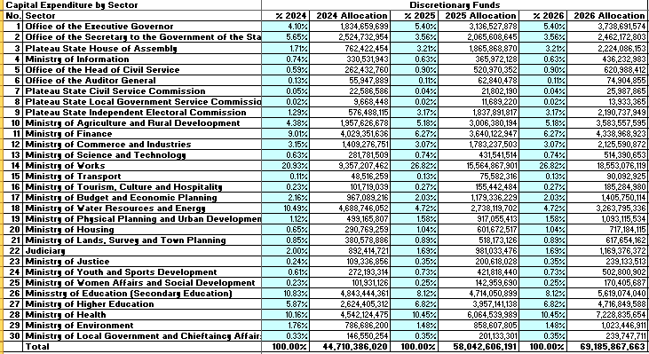

Considerations for the Annual Budget Process
- The budget call circular should include the following instructions to MDAs for the annual budget submissions:
- With a relatively small Capital Development Fund, priority must be given to completing ongoing projects;
- Budget submissions for capital projects must include full life-time capital investment requirements (costs) and also sources of funding (particularly if grants and/or loans are being used to partially / fully fund the project);
- Also, IGR must be clearly presented by source;
- Federal Allocation i.e. SRA, VAT, Re-imbursement etc. must be reflected based on Heads and Sub-Heads as approved;
- Revenue Projections will be guided by Mid-Year actual performance and potentials;
- To ensure effective monitoring and evaluation of government programmes and projects for impact in the State, a robust M&E framework/platform need to be in place and across relevant/key MDAs;
- MDAs should detail out measures and activities to be implemented in 2024-2026 to increase revenue generation and improve collections, Accounting and reporting;
- Revenue units within the MDAs are required to actively participate in generation of revenues for the State;
- All contractual and all forms of Assets and liabilities should be computed and submitted to the Office of the Accountant-General;
- Personnel Cost should be computed based on actual staff strength. Provision for new employment would not be entertained without the approval of the Governor through the Office the Head Civil Service;
- Accurate and updated staff-list must be attached to the Personnel Cost submission containing surname, first-name, other-name, DOFA, DOLA, DOB, next GL, Rank, LGA, Biometric No., and any other information stated;
- All capital receipts and capital expenditure on projects and programmes are to be reflected clearly;
- Status of all capital projects must be stated as completed, or on-going, or roll-over, or either new; a copy of which must be given to the Ministry of Budget and Economic Planning at least two (2) weeks after preceding quarter;
- All projects and programmes must be properly estimated and backed by Bill of Quantities and other relevant documents;
- MDAs are to observe Aggregate Budget Discipline by ensuring their capital submissions adhere strictly to the FSP document, i.e. according to sectorial budget ceilings and based on 3-year Strategic Plan (2022-2024) and policy making of the Five-Pillar Thrusts; and
- All MDAS must submit proposals on or before stipulated datelines for submission.

Summary of Key Points and Recommendations
- We summarise below a list of the key points arising in this document:
- This document and accompanying memorandum and letter should be presented and deliberated by Plateau State EXCO and PLHA respectively. Once approved, the document is published and forms the basis for the preparation of the 2023 budget;
- There should be a more cohesive link between the EFU-FSP-BPS, Plateau State medium term development plan and State Development Strategy 2019-2023;
- Reposition and strengthen the State Bureau of Statistics to produce relevant, timely and reliable data for policy decision making.
- The Fiscal framework in section 3 was elaborated in June 2023 using macroeconomic indicators as at then. However, circumstances impacting on fiscal estimates are dynamic and can change. The price of crude oil, daily production and Naira-Dollar exchange rate for 2024 to 2026 will be determined by the federal Fiscal Strategy Paper (FSP).
- In the light of this, it is recommended to keep the fiscal frame work under review to adjust the revenue projection in December, 2022 to reflect the macroeconomic indicators that will be provided in the approved Federal Fiscal Strategy Paper 2024-2026.

      - Capital Receipts.
Table 5 Estimate of Capital Receipts 2024-2026
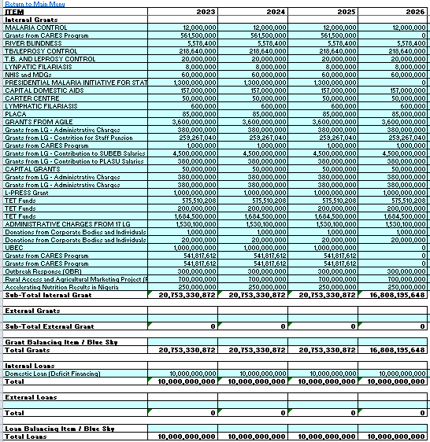

      - References
- IMF - World Economic Outlook Update, October 2022;
- World Bank Global Economic Prospects January 2022;
- African Development Bank West Africa Economic Outlook October 2022;
- OPEC May 2022 Monthly Oil Market Report;
- US Energy Information Administration Short Term Energy Outlook (STEO) May 2022;
- NBS CPI Inflation Report May 2022;
- NBS GDP Report 2022 Q1;
- CBN MPC Communique 142 May 2022;
- CBN Monthly Report January 2022;
- NNPC Monthly Report August 2021 (a little out of date);
- NNPC FAAC Report May 2022;
- December 2021 FAAC Distributions;
- Federal Government 2023-2025 MTEF Final Version;
- Nigeria Economic Sustainability Plan;
- FAAC Schedule 1;
- Plateau State Development Strategy Plan 2019-2023;
- Plateau State Ministry of Finance and Approved Budget – 2016, 2017, 2018 – 2022;
- Plateau State Medium-Term Expenditure Framework 2023-2025;
- State of States report, 2022
- Statista.com

Based on xx PEFA Assessment for Plateau State
Sections 120 and 121 of Constitution of Federal Republic of Nigeria 1999 as amended
Sections 15, 16 and 17 of the PLFRL, 2014
Section 4 of Plateau State Revenue (Consolidation) Law (PSRCL), 2017
* = estimate
Source: world bank

